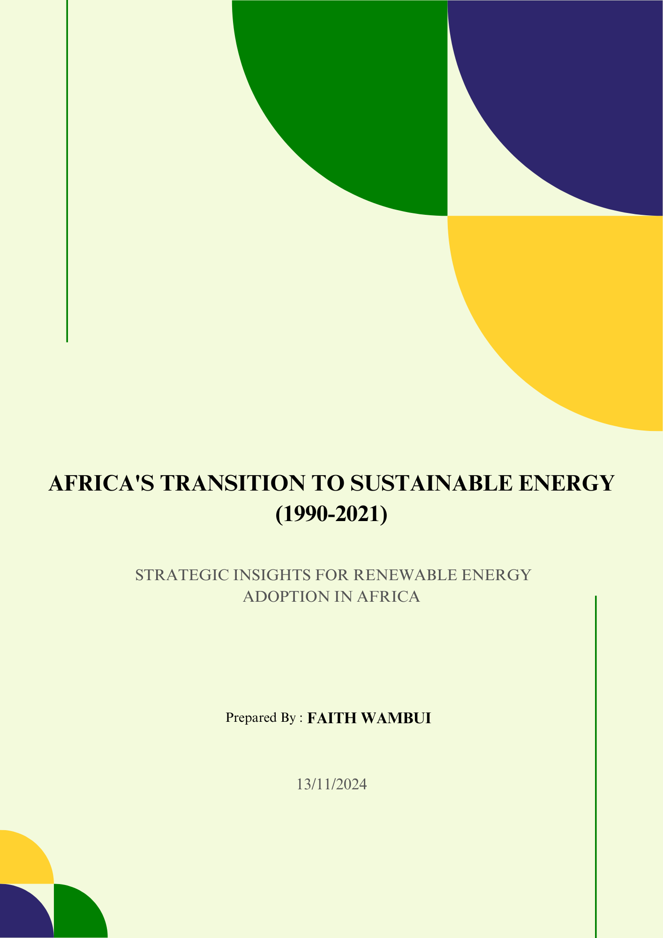

# Executive Summary

## Overview

This report examines Africa's transition to sustainable energy from 1990 to 2021, focusing on:

* Trends in renewable energy consumption as a percentage of total final energy consumption (REC (% of total energy consumption)).
* Key investment opportunities.
* Progress toward Sustainable Development Goal 7 (SDG 7): Affordable and clean energy.
* Economic impacts of renewable energy adoption.
* Regional cooperation frameworks for energy transitions.

The study uses data from the UN SDG Indicators Database and Gapminder, employing statistical and machine learning techniques to derive insights. The findings provide actionable recommendations for policymakers, investors, and stakeholders in Africa's energy sector.

## Highlights

***Varied Adoption Rates****:* Significant disparities exist in REC (% of total energy consumption) across African countries, ranging from near 100% in some nations to below 10% in others.

***Overall Declining Trend:*** Despite individual success stories, African countries' average REC (% of total energy consumption) has declined from 1990 to 2020.

***Economic Impact****:* A weak positive correlation between REC (% of total energy consumption) and GDP growth (0.03) suggests that other factors, such as foreign direct investment (FDI), are critical drivers of economic growth.

***Regional Clusters****:* Countries are grouped into distinct clusters based on their REC (% of total energy consumption) patterns and growth rates, indicating opportunities for targeted regional cooperation. Botswana, Gabon, Comoros, and the Democratic Republic of Congo (DRC) have been identified as potential leaders in renewable energy transitions.

***Top Performers****:* Zimbabwe, Gabon, and Congo, Rep. showed the highest Compound Annual Growth Rates (CAGR) in REC (% of total energy consumption) from 1990 to 2021.

***Kenya's Performance****:* Kenya’s REC (% of total energy consumption) has stabilized between 65% and 75%, indicating a potential for further investment.

## Target Audience

This report provides strategic insights and recommendations to accelerate renewable energy adoption across Africa. It is designed for policymakers, energy sector stakeholders, investors, development partners, and companies looking to contribute to Africa's sustainable energy future.

Table of Contents

Executive Summary 2

Overview 2

Highlights 2

Target Audience 2

1 Introduction 5

Background 5

Objectives 6

Scope 6

2 Literature Review 7

Relevant Research 7

2.1.1 International Energy Agency (IEA), 2022 7

2.1.2 World Bank 7

2.1.3 Renewable Energy Policy Network for the 21st Century (REN21), 2021 8

Theoretical Framework 9

2.1.4 Energy Transition Theory 9

2.1.5 Resource-Based View of Economic Development 10

Gaps in Knowledge 11

3 Methodology 13

Research Design 13

3.1.1 Data Sources and Metrics 13

3.1.2 Data Processing 14

3.1.3 Analysis Techniques 14

3.1.4 Tools Used 14

4 Findings 15

Investment Opportunity Identification 15

Strategic Energy Transition Planning 17

Sustainable Development Goal 7 Alignment 19

Economic Impact Assessment 22

Regional Cooperation Framework 24

5 Case Study: Kenya 26

6 Discussion 28

Analysis of Findings 28

Comparison to Literature 28

Limitations 28

Summary of Key Findings 28

Contribution to Knowledge 29

7 Recommendations 30

Short-term Actions 30

Long-term Strategies 30

Investment Priorities 30

Policy Suggestions 31

Glossary of Technical Terms 32

References 34

Appendices 36

Appendix A: Summary of data tables used in the analysis. 36

Appendix B: Charts of REC trends for each African country. 38

Appendix C: REC CAGR across Countries 1990-2021 48

Appendix D: Box Plots Comparing SDG 7 Indicators between the Top-performing 49

Countries and others in Africa. 49

Appendix E: Regression Results from OLS regression analysis 50

# Introduction

## Background

Africa’s energy landscape is evolving, with the continent facing the dual challenge of meeting growing energy demands while transitioning to more sustainable sources.

The adoption of renewable energy across African countries has evolved significantly in the last two decades, reflecting both the continent's vast potential and the challenges it faces.

As global awareness of climate change and the need for sustainable energy solutions has increased, Africa has emerged as a focal point for renewable energy initiatives. Despite having abundant resources—such as solar, wind, hydropower, and geothermal energy—many African nations still grapple with energy poverty and underdeveloped infrastructure.

This report examines the progress made in renewable energy adoption across African countries from 1990 to 2021.

[africa_progress_map](html_docs/africa_progress_map.html)

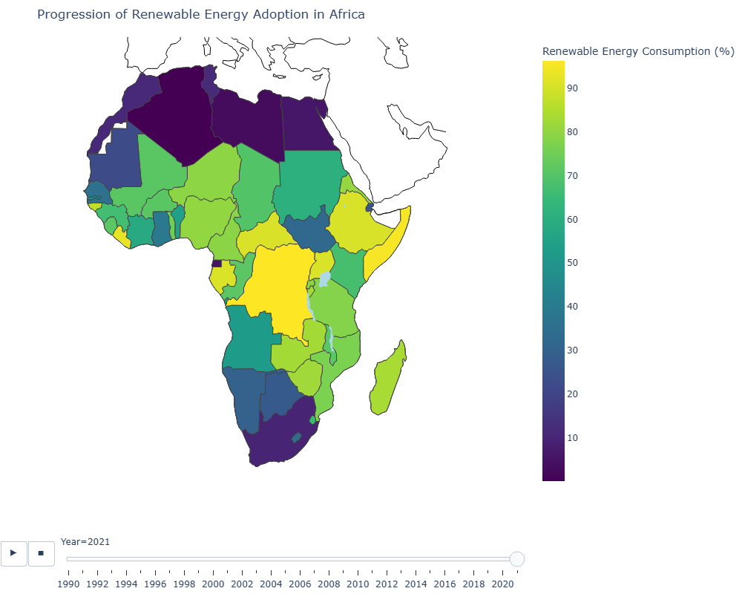

Figure : Map showing the progression of Renewable Energy Adoption in Africa

## Objectives

The primary objective of this report is to analyze Africa’s renewable energy transition from 1990 to 2021. The analysis focuses on several key areas:

1. Investment Opportunity Identification
2. Strategic Energy Transition Planning
3. Sustainable Development Goal 7 Alignment
4. Economic Impact Assessment
5. Regional Cooperation Framework

## Scope

This report covers renewable energy consumption (% of total energy consumption) trends in African countries from 1990 to 2021, focusing on key economic and environmental indicators.

The scope includes a regional analysis, comparative country performance, and an assessment of energy transition strategies.

‘

# Literature Review

## Relevant Research

Renewable energy adoption has been the subject of extensive research globally, with Africa emerging as a key focus area due to its vast renewable energy potential. A few important studies and reports provide insights into renewable energy trends, investment opportunities, and the socioeconomic impacts of renewable energy transitions in Africa.

### International Energy Agency (IEA), 2022

The ***International Energy Agency's (IEA) Africa Energy Outlook 2022*** offers a critical examination of the challenges and opportunities facing Africa's energy sector as it seeks to transition to sustainable energy sources. This report emphasizes the continent's vast potential in renewable energy, particularly solar energy in sub-Saharan Africa, due to its abundant sunlight (International Energy Agency [IEA], 2022).

***Energy Demand and Access****:* According to the IEA, Africa currently has the world's lowest per capita modern energy use. However, population and income growth are projected to drive a 33% increase in energy demand by 2030 in a Sustainable Africa Scenario (IEA, 2022a).

The report highlights that over 600 million people in Africa still lack access to electricity, with nearly 1 billion lacking clean cooking facilities, making the goal of universal access by 2030 a critical focus (IEA, 2022a).

***Renewable Energy Potential****:* Africa possesses 60% of the world’s best solar resources yet accounts for only 1% of installed solar PV capacity. The report projects solar photovoltaic (PV) to be the continent's cheapest power source by 2030, potentially contributing over 80% of new generation capacity. Solar, alongside other renewable sources such as wind, hydropower, and geothermal, could significantly enhance energy access and sustainability (IEA, 2022b).

***Investment and Infrastructure Needs***: The IEA underscores the necessity for substantial investment—over USD 190 billion annually from 2026 to 2030—in clean energy infrastructure. This financial commitment is essential to build resilient systems capable of meeting rising demands, particularly in sub-Saharan regions (IEA, 2022b). Furthermore, regional cooperation is identified as a key strategy to enhance energy integration and resource distribution (IEA, 2022c).

***Challenges and Opportunities****:* While financial limitations, political challenges, and fossil fuel dependencies pose barriers, the IEA also highlights economic growth potential through renewable energy investment. To navigate these challenges, African nations are encouraged to adopt clear strategies supported by international funding (IEA, 2022d).

In summary, the ***Africa Energy Outlook 2022*** provides an essential roadmap for Africa's energy transition, underscoring the pivotal role of renewable energy in achieving sustainable development and expanding energy access across the continent.

### World Bank

The World Bank's report, ***Rethinking Power Sector Reform in the Developing World,*** authored by Vivien Foster and Anshul Rana, provides an in-depth analysis of power sector reforms, particularly within African countries.

This report utilizes case studies to explore how regulatory frameworks, financing mechanisms, and governance influence the integration of renewable energy into national grids (Foster & Rana, 2020).

***Key Findings:***

***Regulatory Frameworks****:* The report emphasizes that regulatory measures, while widely adopted, often fall short of expectations due to challenges in implementation. Effective regulation is essential for renewable energy integration and helps power sectors adapt to emerging technologies and market dynamics (Foster & Rana, 2020).

***Financing Challenges****:* Access to finance is identified as a persistent barrier to modernizing power sectors. While private sector investment has increased generation capacity, distribution efficiency remains low, underscoring the need for innovative financing tailored to each country's context (Foster & Rana, 2020).

***Governance Structures***: Good governance emerges as a key determinant of reform success. Countries with strong governance frameworks are more likely to achieve positive outcomes, including the integration of renewable energy sources. The report highlights that governance reforms should be prioritized, especially in environments where financial viability is still being developed (Foster & Rana, 2020).

***Policy Implications***

The report suggests that reform efforts should be tailored to each country's unique political and economic conditions. Instead of a one-size-fits-all model, the study advocates for a pluralistic approach that allows flexibility in reform pathways. This perspective aligns with the growing emphasis on context-sensitive reforms in developing economies and recognizes the evolving energy landscape of the 21st century (Foster & Rana, 2020).

In conclusion, ***Rethinking Power Sector Reform in the Developing World*** provides valuable insights into power sector reform's complexities, especially in African countries, and underscores the importance of regulatory frameworks, financing solutions, and governance structures for integrating renewable energy.

### Renewable Energy Policy Network for the 21st Century (REN21), 2021

The ***Renewables 2021 Global Status Report*** by REN21 provides a comprehensive analysis of the global renewable energy landscape, with a focus on Africa’s growth potential in this sector.

The report highlights several key findings that underscore the need for aggressive policy reform to expedite the global transition to renewable energy across all sectors (REN21, 2021a).

***Overview of Global Renewable Energy Progress***

The report emphasizes that despite incremental progress, fossil fuels continue to dominate global energy consumption, maintaining a share of approximately 80% over the last decade (REN21, 2021b).

In 2020, the world witnessed a notable increase in renewable energy capacity, despite the challenges posed by the COVID-19 pandemic, which has significant implications for achieving net-zero emissions and sustainable development goals (REN21, 2021c).

***Focus on Africa***

Africa is identified as having substantial renewable potential, particularly in solar, wind, and hydropower. Kenya, South Africa, and Morocco are recognized as leaders in this energy transition, driven largely by policy reforms and foreign investment (REN21, 2021d).

The report advocates for establishing supportive policies and frameworks to harness this potential effectively, recommending that renewable energy be integrated as a key performance indicator in national strategies to assess climate progress (REN21, 2021e).

***Recommendations***

REN21 urges governments to prioritize renewable energy in post-COVID-19 economic recovery strategies, which includes setting renewable energy shares as essential indicators for climate progress (REN21, 2021f).

The report also calls for enhanced international cooperation and investment in renewable technologies to accelerate the transition from fossil fuels, especially in developing regions such as Africa (REN21, 2021g).

In summary, the ***Renewables 2021 Global Status Report*** is a vital resource for understanding the current state of renewable energy worldwide. It emphasizes the need for immediate policy action and investment to unlock Africa’s vast renewable energy potential.

## Theoretical Framework

The renewable energy transition in Africa can be analyzed through the lens of the ***Energy Transition Theory***, which posits that economies must shift from high-carbon energy sources to renewable energy to ensure sustainable growth. This shift involves various stages, starting with policy incentives, moving toward market-driven growth, and ultimately resulting in widespread adoption.

The ***Resource-Based View (RBV*)** of economic development also highlights how Africa's natural resources, such as solar and wind, can be leveraged for growth.

### Energy Transition Theory

Energy Transition Theory underscores the necessity for supportive policies, market incentives, and technological innovation to facilitate the large-scale adoption of renewable energy. This theory is fundamental in understanding the shift from fossil fuels to sustainable energy sources, addressing both environmental and economic challenges.

***Key Components of Energy Transition Theory***

***Supportive Policies***: Governmental policies are essential for a successful energy transition, including regulations that promote renewable energy, financial incentives such as subsidies, and carbon pricing mechanisms. For instance, Cherp et al. (2018) highlight the importance of government intervention in stimulating renewable energy markets, asserting that significant transitions are unlikely without such support (Cherp et al., 2018; Korea Energy Economics Institute, 2023).

***Market Incentives****:* Market mechanisms aligned with sustainability goals encourage investments in renewable technologies while gradually eliminating fossil fuel subsidies. The International Renewable Energy Agency (IRENA) notes that substantial investments—estimated at USD 150 trillion by 2050—are necessary to meet climate targets, requiring a redirection of funds from fossil fuels to renewable energy sources (IRENA, 2023).

***Technological Innovation****:* Technological advancement is essential for enhancing efficiency and lowering the costs of renewable energy deployment. Research shows that innovations in technology can reduce adoption barriers, making renewable energy sources more competitive against traditional energy (United Nations Development Programme [UNDP], 2023; Berkhout, 2023).

***Pathways for Energy Transition***

Cherp et al. (2018) propose a meta-theoretical framework that integrates techno-economic, socio-technical, and political perspectives to analyze national energy transitions. This approach emphasizes the complex interactions among various stakeholders and highlights the need for multi-faceted policy design (Cherp et al., 2018; Ministry of Energy Kenya, 2023).

***Challenges and Barriers***

Despite the potential benefits of an energy transition, significant challenges remain:

* **Resistance from Established Interests**: Incumbent industries may resist changes that threaten their market position.
* **Investment Gaps**: Current investment levels are insufficient to meet climate goals.
* **Policy Inconsistencies**: While some regions advance renewable policies, others continue supporting fossil fuels, undermining global efforts (IRENA, 2023; Berkhout, 2023).

***Conclusion***

The success of Energy Transition Theory depends on a coordinated approach involving policies and market participation. Addressing structural barriers and ensuring socio-economic benefits are essential for technologies, and achieving a sustainable energy future. As highlighted by IRENA, the urgency of this transition cannot be overstated, and proactive measures are crucial for aligning current practices with long-term sustainability goals (IRENA, 2023).

### Resource-Based View of Economic Development

The Resource-Based View (RBV) is a strategic framework emphasizing the significance of a firm's internal resources and capabilities as primary drivers of competitive advantage and economic performance. This perspective is especially relevant in resource-rich regions like Africa, where effectively managing and utilizing resources can foster sustainable economic growth (Oxford Reference, 2021).

***Key Concepts of the Resource-Based View***

***Heterogeneity of Resources****:* RBV asserts that firms possess diverse resources that are not uniformly distributed among competitors. This heterogeneity allows firms to adopt strategies uniquely suited to their resource mix, resulting in varying success levels in exploiting market opportunities (Oxford Reference, 2021; Study.com, 2021).

***VRIN Criteria****:* Resources that provide a sustainable competitive advantage must meet four criteria: they should be Valuable, Rare, Imperfectly Imitable, and Non-substitutable (ScienceDirect, 2021). For instance, a resource must allow a firm to exploit opportunities or mitigate threats, be difficult for competitors to replicate, and have no substitutes capable of fulfilling the same function (Wikipedia, 2021).

***Core Competencies****:* Firms should cultivate core competencies, unique strengths that differentiate them from competitors. These competencies arise from combining tangible and intangible resources, including technology, skilled labour, and organizational culture (University of Illinois, 2021).

***Application of RBV in Africa's Economic Development***

In Africa, RBV suggests that leveraging renewable resources like solar, wind, and geothermal energy can be pivotal for economic growth. With an abundance of renewable resources, effective management could significantly improve energy access and sustainability.

***Importance of Renewable Resources***

***Sustainable Growth****:* Investment in renewable energy aligns with global sustainability trends, reducing dependence on fossil fuels and enhancing energy security for African nations (Science Direct, 2021).

***Job Creation****:* Developing the renewable energy sector can generate jobs, support local economies and improve livelihoods (Oxford Reference, 2021; University of Illinois, 2021).

***Technological Innovation****:* Renewable energy technology promotes innovation, attracting foreign investment and further driving economic development (University of Illinois, 2021).

***Challenges and Considerations***

Despite the potential for renewable resources, challenges such as infrastructure development, investment needs, and policy frameworks must be addressed to enable effective deployment and equitable resource distribution (Study.com, 2021; University of Illinois, 2021).

In conclusion, the **Resource-Based View** offers a valuable framework for understanding how Africa can leverage its natural resources for economic development. By focusing on renewable energy and sustainable practices, African nations can harness their unique resource endowments for growth, job creation, and innovation.

## Gaps in Knowledge

Despite a growing body of research on renewable energy, there are still notable gaps when it comes to Africa's specific challenges. For instance, studies on the relationship between renewable energy adoption and foreign direct investment (FDI) remain sparse. Additionally, the impact of renewable energy on GDP growth in the African context is less understood compared to other regions, with few empirical studies addressing long-term economic impacts of renewable energy transitions.

Moyo and Billon (2021) emphasize significant data gaps concerning the effectiveness of renewable energy projects in Africa, especially regarding their economic impact. They argue for more comprehensive studies to explore how renewable energy adoption intersects with economic policy and regional development, which is crucial for understanding the broader implications of renewable energy beyond environmental benefits, focusing instead on economic sustainability and growth.

***Key Findings from Moyo and Billon (2021)***

***Data Gaps****:* Many African nations lack detailed data on the economic impacts of renewable energy initiatives, hindering effective policy-making and project implementation (Moyo & Billon, 2021).

***Call for Research****:* Moyo and Billon advocate for more in-depth studies on the connections between renewable energy projects, economic policies, and regional development outcomes. Such research is essential for understanding renewable energy's potential contributions to economic sustainability and growth (Moyo & Billon, 2021).

***Policy Implications***: Without a thorough understanding of these dynamics, the authors suggest that policymakers may struggle to design effective interventions that leverage renewable energy for economic development.

***Broader Context***

Moyo and Billon’s discussion aligns with ongoing research on the socio-economic impacts of renewable energy. For example, studies show that renewable energy can lead to job creation and market stabilization, but project success often depends on supportive government policies and technological innovation (Energies, 2023; FEPBL, 2022). Additionally, regional variations in institutional capacity may influence renewable energy initiatives' success, suggesting that localized strategies could be essential for optimizing outcomes (BioMed Central, 2021; MDPI, 2023).

In summary, Moyo and Billon’s work highlights the need for comprehensive data collection and analysis to inform policies that effectively harness renewable energy for economic growth in Africa.

# Methodology

## Research Design

This report follows a quantitative research design, using historical data to analyze trends in REC (% of total energy consumption) and economic indicators. The study employs exploratory data analysis (EDA) to identify patterns and relationships in the data.

### Data Sources and Metrics

The analysis drew from two primary data sources:

**UN SDG Indicators Database**

URL:<https://unstats.un.org/sdgs/dataportal/database>

Access Method: API

License: CC-BY

Key Metrics:

* Proportion of population with access to electricity (%) Proportion of population with primary reliance on clean fuels and technology (%)
* Renewable energy share in the total final energy consumption (%)
* Energy intensity level of primary energy (Mega Joules per constant 2017 purchasing power parity GDP)
* Installed renewable electricity-generating capacity (watts per capita)
* International financial flows to developing countries in support of clean energy research and development and renewable energy production, including in hybrid systems (millions of constant 2021 United States dollars)

**Gapminder Database**

URL:<https://www.gapminder.org/data/>

Access Method: CSV download

License: CC-BY

Key Metrics:

* Foreign Investment inflows (direct, net % of GDP)
* GDP per capita (Price and inflation-adjusted in PPP$2017)
* GDP

### Data Processing

The data processing involved several steps to prepare the datasets for analysis:

***Data Cleaning and Transformation****:*

* Transposing data to switch rows and columns
* Filtering for specific years (1990-2021)
* Removing unnecessary columns
* Filtering for African countries
* Handling missing data by deleting incomplete rows
* Renaming columns for clarity
* Converting figures from shorthand formats (M, B, K) to whole numbers

***Data Enrichment****:*

* Calculating Compound Annual Growth Rate (CAGR) and Growth Rate for GDP and REC (% of total energy consumption)
* Merging multiple datasets for a comprehensive view

### Analysis Techniques

The analysis employed various statistical and machine learning techniques:

* ***Descriptive Statistics****:* To summarize and describe the basic features of the data.
* ***Time Series Analysis****:* To examine trends and patterns in REC (% of total energy consumption) over time.
* ***Correlation Analysis****:* To measure the strength and direction of relationships between variables.
* ***Regression Analysis****:* To model the relationship between REC (% of total energy consumption) and economic indicators.
* ***Cluster Analysis****:* To group countries with similar renewable energy adoption patterns.
* ***T-tests****:* To compare differences between groups of countries.

### Tools Used

The primary tool used for data analysis was Python in Jupyter Notebook.

Key libraries utilized include:

* *Pandas:* For data manipulation and analysis
* *NumPy:* For numerical computing
* *Matplotlib and Seaborn:* For data visualization
* *Scikit-learn:* For machine learning algorithms (clustering)
* *Statsmodels:* For statistical modelling and econometrics

# Findings

## Investment Opportunity Identification

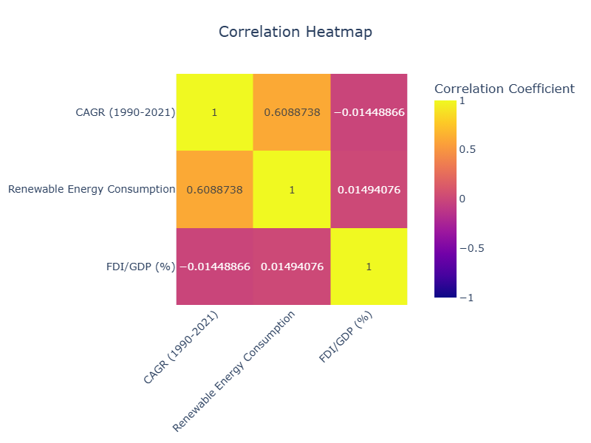***Relationship*** ***between Investment and Renewable Energy***

Figure 2: Heat map showing correlation between REC, CAGR and FDI/GDP

The analysis examined the relationship between foreign direct investment (FDI/GDP), renewable energy consumption (REC), and renewable energy growth rates.

A weak positive correlation (0.01494) was found between the FDI to GDP ratio and the share of total energy consumption from renewable sources (REC). This implies there is almost no linear relationship between levels of foreign investment and the prevalence of renewable energy in the energy mix.

The analysis did find a moderate positive correlation (0.6088) between REC and the compound annual growth rate (CAGR) of renewable energy. This suggests that countries with higher growth rates in renewable energy tend to have slightly higher shares of renewable energy consumption, though the relationship is not extremely strong.

Conversely, a weak negative correlation (-0.0148) was observed between FDI to GDP ratios and the CAGR of renewable energy. This indicates that higher levels of foreign investment are slightly associated with lower growth rates in renewable energy, though again the relationship is not particularly strong.

Overall, the data points to an inconsistent relationship between foreign investment, the current renewable energy mix, and the pace of renewable energy growth across countries.

Other factors beyond just investment levels likely play a bigger role in shaping renewable energy development.

***Growth vs. Investment****:*

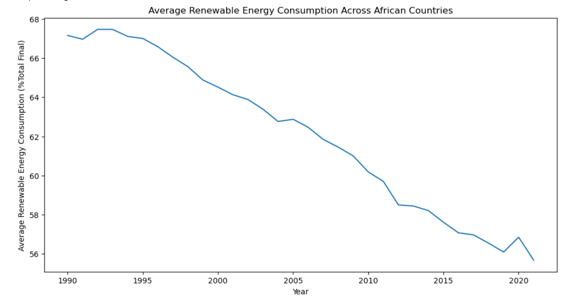

Figure : Average REC across African Countries from 1990-2021

The analysis revealed that most countries showed a decline in the share of total energy consumption from renewable sources (REC) over the period from 1990 to 2021, despite varying levels of investment attractiveness across those nations (see Appendix B for details).

[risk-reward matrix](html_docs/risk-reward%20matrix.html)

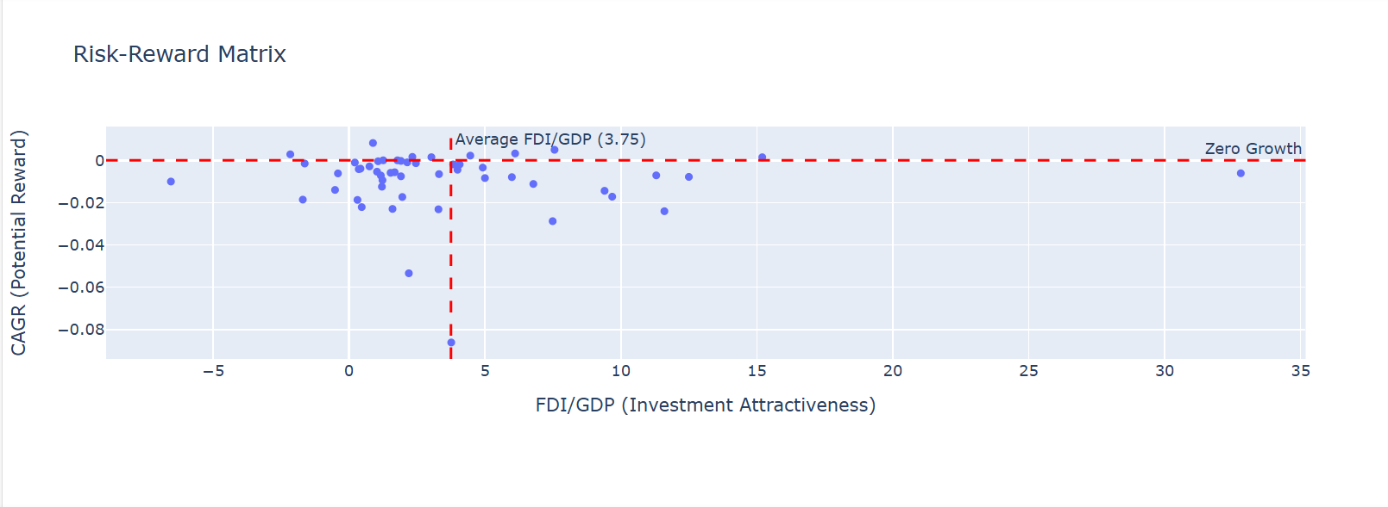

Figure : Risk-Reward Matrix showing the Investment Attractiveness based on REC Growth between 2016 and 2021

However, the data did identify some potential investment opportunities in regions that exhibited positive growth rates in renewable energy coupled with above-average FDI to GDP ratios (see Appendix C). The countries that emerged as having relatively low risk but higher reward investment opportunities in this area were Cape Verde, Somalia, Gabon, and Liberia.

This suggests that while broader trends point to declining renewable energy shares, there are still pockets of high growth and investment potential that warrant further exploration. The key is identifying those markets that have both the momentum in renewable development as well as the investment climate to effectively capitalize on it.

## Strategic Energy Transition Planning

***Overall Trend***

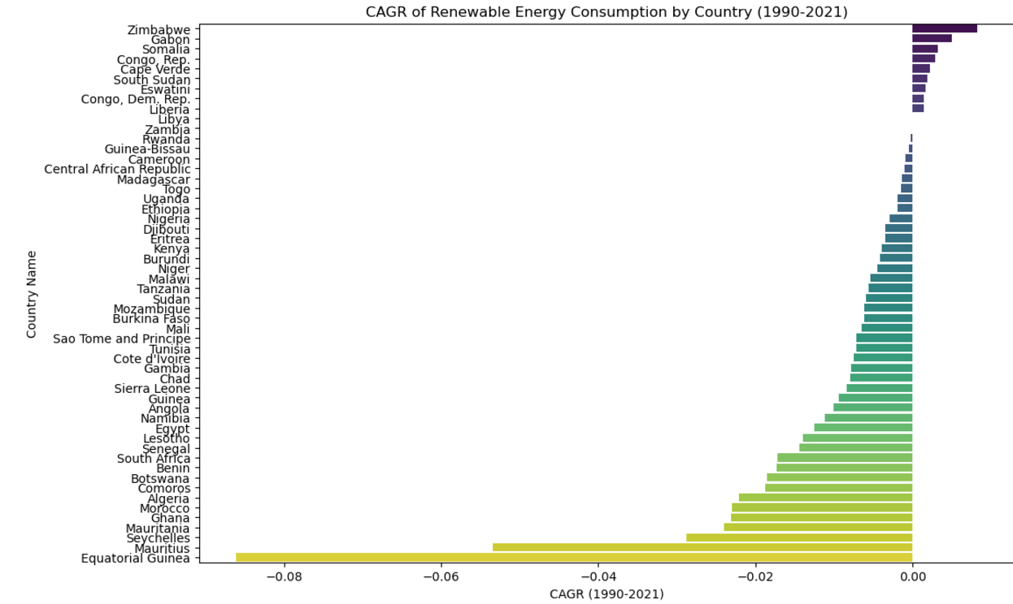

Figure : CAGR of REC by Country (1990-2021)

The analysis revealed an overall downward trend in renewable energy consumption across the countries studied. The average compound annual growth rate (CAGR) from 1990 to 2021 was -0.91%, indicating a general decline in the share of total energy consumption coming from renewable sources (REC) over this period.

***Country Performance (****Appendix C****)***

While the broader trend was negative, a few countries did manage to post positive growth rates in renewable energy consumption:

* Zimbabwe had the highest CAGR at 0.82%
* Gabon saw a 0.50% CAGR
* Somalia achieved a 0.32% CAGR

These countries are well-positioned for future investments, particularly in solar and wind energy sectors.

In contrast, several countries experienced significant declines in their renewable energy shares:

* Equatorial Guinea had the lowest CAGR at -8.61%
* Mauritius saw a -5.34% CAGR
* Seychelles declined at a rate of -2.88% CAGR

This wide variation in country-level performance highlights the need for tailored, strategic energy transition planning to address the unique circumstances and resource profiles of each market. Identifying both the high-growth and struggling renewable energy markets will be critical for informing effective policy and investment decisions.

***Cluster Analysis****:*

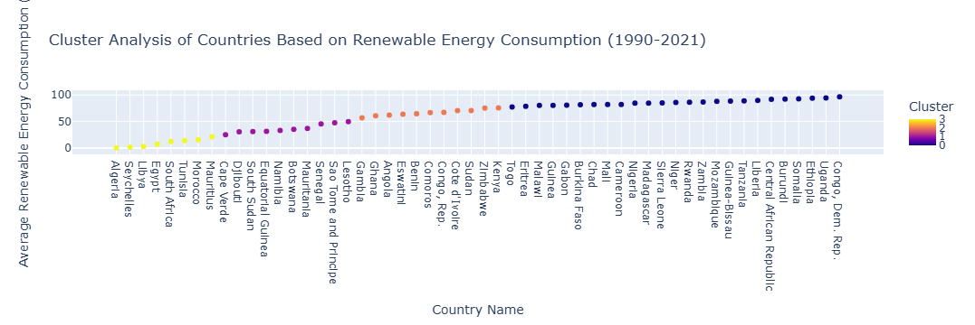

Figure : Cluster Analysis of Countries based on REC (1990-2021)

Countries were grouped into four clusters based on their renewable energy consumption (REC) as a percentage of total energy consumption:

*Cluster 3 (Yellow):* This cluster includes countries like Algeria, Seychelles, and Libya, which have extremely low renewable energy consumption, falling under the 0-20% range.

*Cluster 2 (Orange):* This cluster encompasses countries with significant reliance on renewable energy sources, such as Angola, Ghana, and Kenya. Their renewable energy consumption rates fall between 60-75%.

*Cluster 1 (Purple):* Countries like Lesotho, South Sudan, and Botswana fall into this cluster, with moderate renewable energy consumption levels ranging from 25-50%.

*Cluster 0 (Dark Blue):* This cluster is dominated by countries like the Democratic Republic of Congo, Uganda, and Ethiopia, which have the highest levels of renewable energy consumption, ranging from 76-100%.

***Key Observations***

* The countries with the highest renewable energy consumption, close to 100%, are predominantly located in East and Central Africa, such as the Democratic Republic of Congo, Uganda, Burundi, Somalia, and Ethiopia.
* In contrast, the countries with the lowest renewable energy consumption, close to 0%, are primarily located in North Africa, including Algeria, Libya, and Egypt. South Africa, as a large economy, also falls into this low-performing category.
* The small island nation of Seychelles stands out as an outlier, with very low renewable energy use compared to other small countries.

Overall, the data reveals a stark divide in renewable energy reliance across the African continent, with certain regions and countries significantly outperforming others. Understanding these regional patterns and identifying the drivers behind the high and low performers will be crucial for informing strategic energy transition planning.

## Sustainable Development Goal 7 Alignment

***SDG 7 Indicator Correlations****:*

*[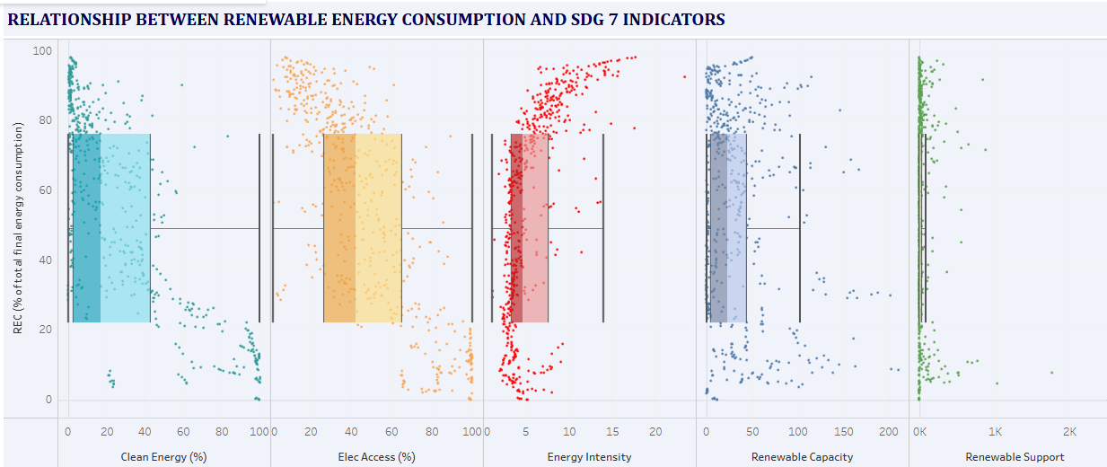](https://public.tableau.com/views/RENEWABLEENERGYCONSUMPTIONANDSDG7INDICATORS/Sheet1?:language=en-US&:sid=&:redirect=auth&:display_count=n&:origin=viz_share_link)*

Figure : Box plot showing relationship between REC and SDG7 Indicators

*Clean Energy vs. Renewable Energy Consumption (Turquoise):*

The data suggests there is a positive correlation between the percentage of clean energy in a country's energy mix and its overall renewable energy consumption (REC). Most data points cluster between 0-80% for clean energy, and the spread indicates that countries with higher clean energy shares tend to have higher renewable energy consumption levels.

*Electricity Access vs. Renewable Energy Consumption (Orange)*

The analysis revealed a wide spread of electricity access rates, ranging from 0-100%, across the countries studied. However, there does not appear to be a clear, strong correlation between a country's electricity access rate and its level of renewable energy consumption. Many countries show varying REC levels despite having high rates of electricity access.

*Energy Intensity vs. Renewable Energy Consumption (Red)*

An interesting pattern emerged where higher energy intensity generally corresponds to lower renewable energy consumption. This inverse relationship implies that more energy-intensive economies might be less reliant on renewable sources. The data points are also more densely clustered at lower energy intensity values.

*Renewable Capacity vs. Renewable Energy Consumption (Blue)*

The relationship between a country's renewable energy capacity and its actual renewable energy consumption appears scattered and not clearly defined. The wide spread suggests that having significant renewable energy capacity does not necessarily translate directly to high levels of renewable energy consumption.

*Renewable Energy Support vs. Renewable Energy Consumption (Green)*

This particular analysis had a more limited dataset, and the relationship between renewable energy support policies and renewable energy consumption is not clearly articulated in the visualization.

***Key Observations***

The relationships between these various indicators and renewable energy consumption are complex and not always linear. The strongest positive correlation seems to be between clean energy adoption and renewable energy consumption. Energy intensity, on the other hand, appears to have a more inverse relationship with renewable energy use. Capacity alone does not guarantee high renewable energy consumption, and electricity access does not solely determine renewable energy levels either. Overall, these insights highlight the nuanced factors at play in driving renewable energy transition across different countries.

***Top Performing Countries****:*

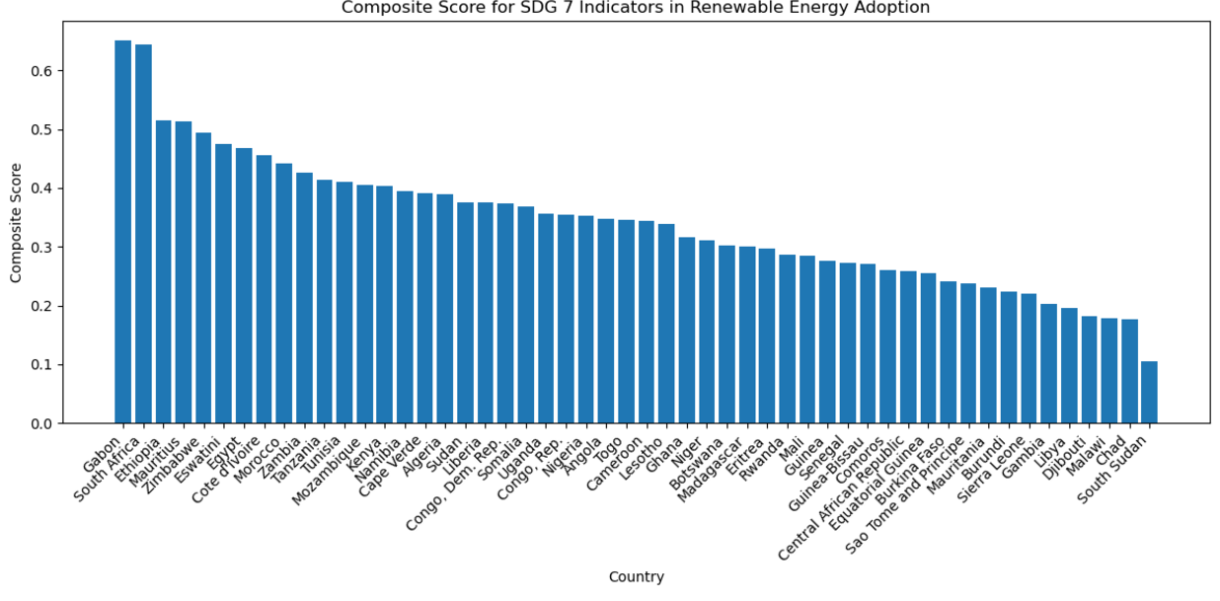

Figure : Chart showing the Composite Score of the SDG7 Indicators in Renewable energy Adoption

*Gabon and South Africa Lead with High Composite Scores*

The analysis revealed that Gabon and South Africa emerged as the leading countries, with composite scores above 0.6. This indicates they have made significant progress on the key indicators evaluated.

*Top Performing Countries*

Beyond Gabon and South Africa, the top performing countries were identified as:

1. Gabon Composite Score: 0.65 Progress Level: High
2. Zimbabwe Composite Score: 0.49 Progress Level: Moderate
3. Eswatini Composite Score: 0.47 Progress Level: Low

These countries demonstrated the highest overall composite scores, suggesting they have achieved more advanced levels of development and performance across the various renewable energy metrics analyzed.

The composite scores and assessed progress levels provide a holistic view of each country's standing in the renewable energy transition. This insight can help inform strategic planning and investment decisions aimed at accelerating the clean energy transformation across the region.

|  |  |  |
| --- | --- | --- |
| Country | Composite Score | Progress |
| Gabon | 0.650817 | 18.5 |
| Zimbabwe | 0.494736 | 12.9 |
| Eswatini | 0.473948 | 5.3 |

Table : Table of the Top 3 Performing Countries showing their Composite Score and Progress

***Performance Comparison****:*

*The Top Performers Stand Out in Renewable Capacity and Clean Energy*

Upon further examination, the data revealed that the top performing countries, as identified by their high composite scores, showed significantly higher levels of renewable energy capacity and clean energy percentages compared to the other countries analyzed (see Appendix D for details).

This suggests that the ability to develop and deploy substantial renewable energy generation infrastructure has been a key driver of the top performers' progress in the renewable energy transition.

*Differences in Electricity Access and Energy Intensity Less Pronounced*

However, the analysis also found that the differences in electricity access rates and energy intensity metrics were not statistically significant between the top performing countries and the rest of the group.

This indicates that factors beyond just electrification levels and overall energy efficiency are playing a key role in determining a country's success in transitioning to renewable energy sources. Other variables, such as policy frameworks, investment climate, and resource endowments, may be more influential in shaping renewable energy outcomes.

These insights underscore the multifaceted nature of the renewable energy transition. While building out substantial renewable energy capacity appears to be a hallmark of the top performers, achieving broader progress requires a holistic approach that addresses a range of interconnected economic, infrastructural, and policy-related considerations.

## Economic Impact Assessment

***Renewable Energy and GDP Growth****:*

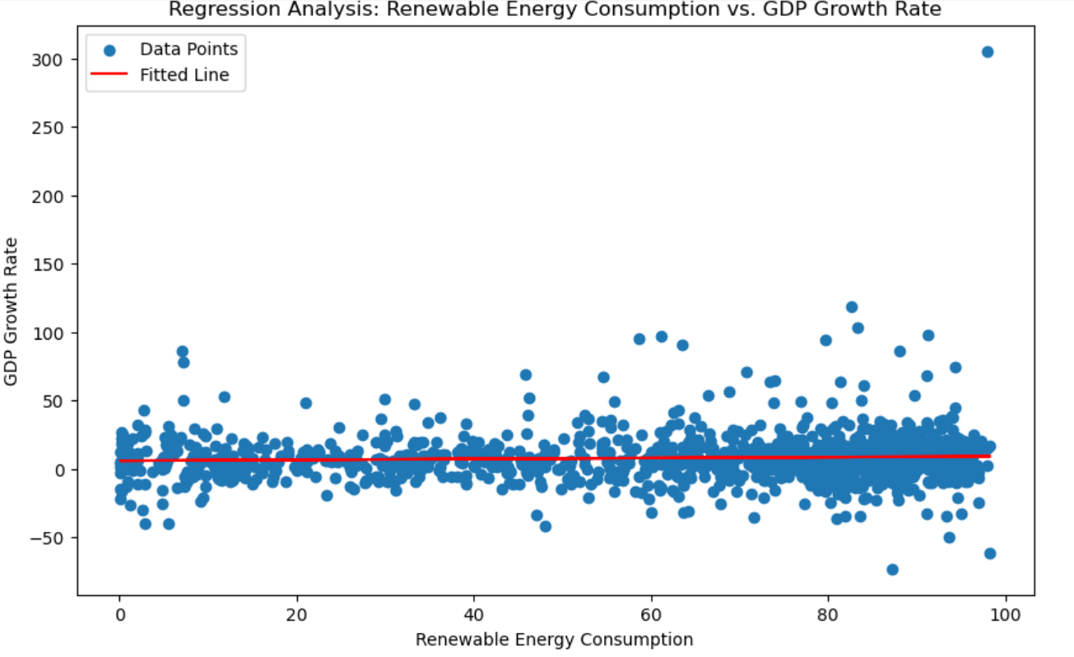

Figure : Regression Analysis of REC vs GDP Growth Rate

The analysis explored the relationship between a country's share of renewable energy consumption (REC) as a percentage of total energy consumption and its GDP growth rate.

The data revealed a very weak positive correlation (0.03) between these two variables. This suggests there is almost no linear relationship between a country's renewable energy consumption levels and its economic growth rate.

To further examine this, a regression analysis was conducted. The results showed that REC (% of total energy consumption) only explains a small portion, about 4.6%, of the variation observed in GDP growth rates across the countries studied.

This indicates that factors beyond just renewable energy consumption are much more influential in driving a country's economic growth. Other macroeconomic, policy, and resource-related variables likely play a bigger role in shaping GDP growth rates.

The lack of a strong, direct correlation between renewable energy use and GDP growth underscores the complexity of the relationship between a country's energy transition and its broader economic performance. Policymakers and planners should consider a more holistic set of indicators when assessing the potential economic impacts of renewable energy deployment.

***FDI Impact****:*

In contrast, the data showed a more consistent positive relationship between a country's FDI to GDP ratio and its GDP growth, especially at 1-year and 3-year lags (see Appendix E for details).

The correlation analysis revealed that FDI has a more significant and positive impact on GDP growth, particularly in the shorter and medium-term timeframes, compared to the country's renewable energy consumption levels.

These findings indicate that while renewable energy development is an important part of the energy transition, it may not directly translate to measurable economic gains in the same way that foreign direct investment does. Policymakers and planners should consider a more holistic set of economic indicators beyond just renewable energy consumption when assessing a country's growth prospects and development strategies.

***Country-specific Analysis****:*

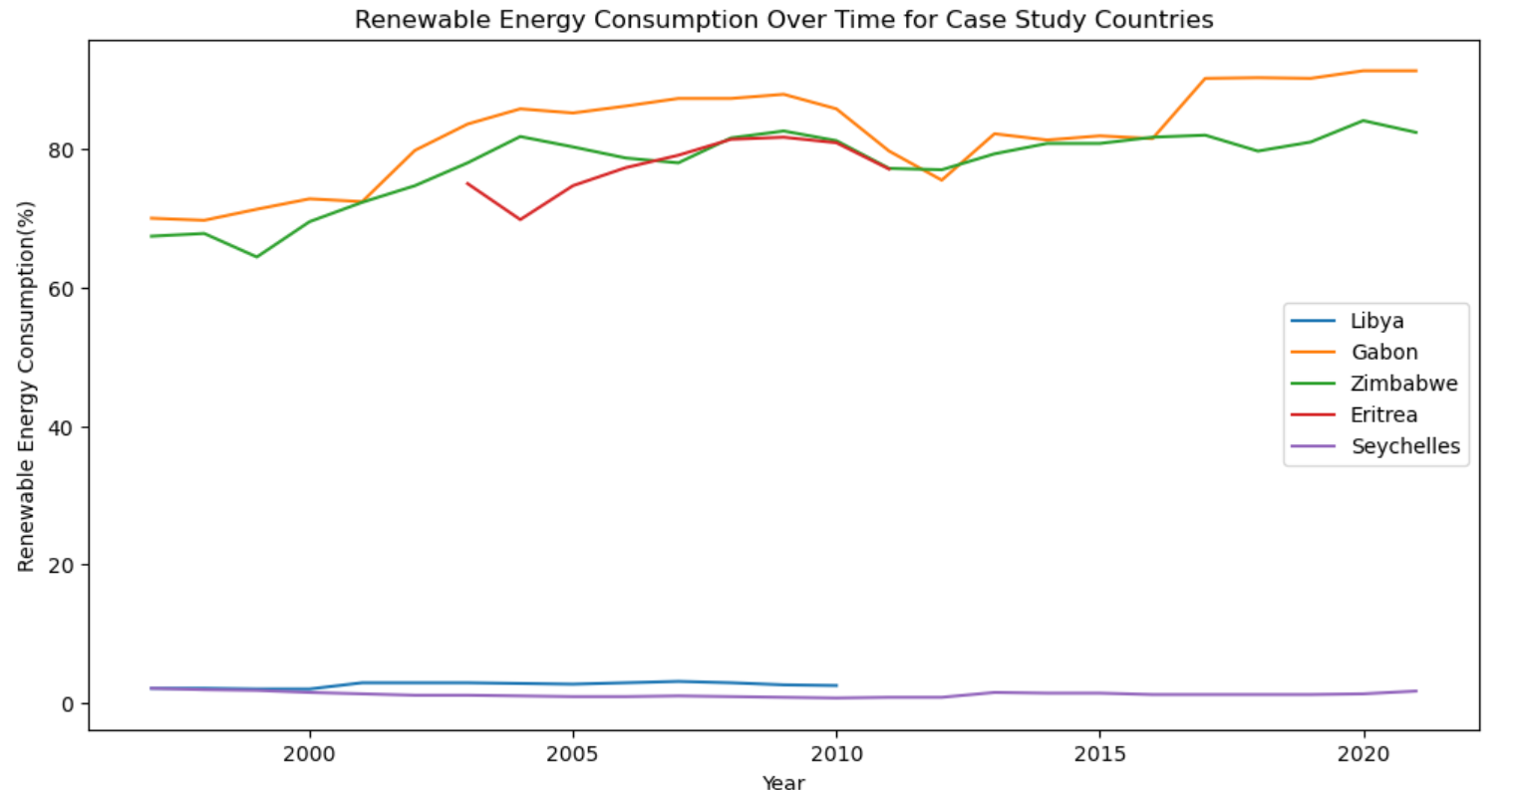

Figure : REC for the Top 5 Countries

The analysis identified the top 5 countries that have achieved significant growth in renewable energy consumption:

1. Zimbabwe
2. Gabon
3. Republic of Congo
4. Eswatini
5. Liberia

These countries stand out for their impressive strides in expanding their renewable energy footprint over the time period studied.

However, the patterns of renewable energy consumption (REC) as a percentage of total energy consumption varied across these growth leaders:

* Gabon and Zimbabwe demonstrated general upward trends in their REC levels over time.
* The other three countries - Republic of Congo, Eswatini, and Liberia - exhibited more mixed or fluctuating REC trends.

This suggests that the pathways to growing renewable energy can differ, with some countries seeing more linear progress while others experience more volatility in their renewable energy shares.

Nonetheless, the identification of these top renewable energy growth performers provides valuable insights. Understanding the unique drivers, policies, and market conditions that have enabled their progress can inform strategies to replicate and scale similar renewable energy transitions in other parts of the region.

## Regional Cooperation Framework

***Cluster Analysis for Regional Cooperation****:*

[*country_clusters*](html_docs/country_clusters.html)

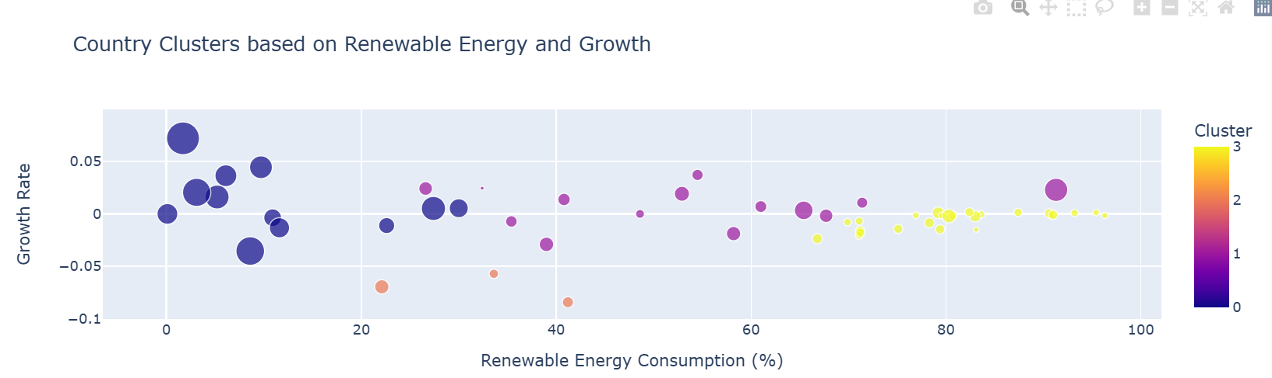

Figure : Hierarchical Country Clusters based on REC and the Growth Rate

The analysis grouped the countries into four distinct clusters based on their renewable energy consumption (REC) levels and growth rates:

* Cluster 0 (Blue): Low Consumption, High Growth

This cluster includes countries like Botswana and South Africa, which have relatively low REC percentages but are experiencing high growth rates in renewable energy.

* Cluster 1 (Purple): Low Consumption, Low Growth

Countries in this cluster, such as Angola and Ghana, have both low REC levels and low growth rates in renewable energy.

* Cluster 2 (Orange): Moderate Consumption, Moderate Growth

The countries in this cluster, including Comoros and Lesotho, exhibit moderate levels of renewable energy consumption and growth.

* Cluster 3 (Yellow): High Consumption, Low Growth

This cluster is dominated by countries like the Democratic Republic of the Congo and Ethiopia, which have very high REC percentages but low growth rates in renewable energy.

This clustering reveals the diverse pathways countries are taking in their renewable energy transitions. Some are starting from a low base but rapidly expanding their renewable energy footprint, while others have already achieved high renewable energy shares but are struggling to sustain growth. Understanding these distinct groupings can help inform tailored policy interventions and investment strategies to accelerate the clean energy transformation across the region.

***Potential Regional Leaders****:*

*[regional_leaders](html_docs/regional_leaders.html)*

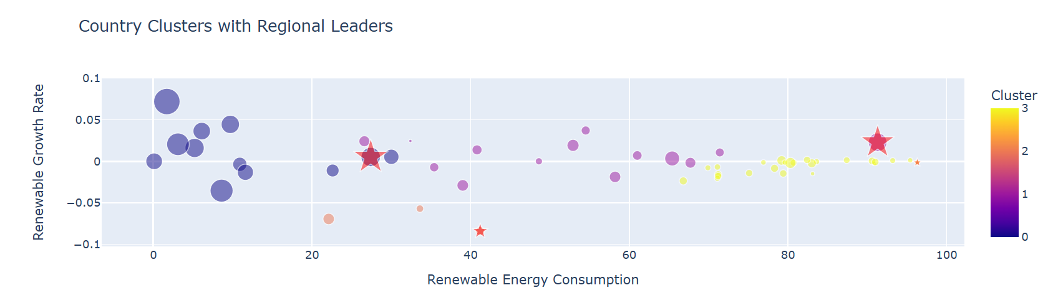

Figure : Hierarchical Country Cluster Leaders based on REC and the Growth Rate

The cluster analysis revealed several potential regional leader country profiles within each grouping:

Botswana (Cluster 0): This country exhibits high growth rates in renewable energy despite having only moderate GDP per capita levels. Its position in the "low consumption, high growth" cluster suggests it is a rising renewable energy performer.

Gabon (Cluster 1): As a "high consumption, high growth" country, Gabon stands out with its combination of substantial renewable energy use and rapid expansion of its renewable sector. Its high GDP per capita also indicates strong economic resources to support the energy transition.

Comoros (Cluster 2): This "moderate consumption, negative growth" country has low GDP per capita, pointing to potential challenges in sustaining renewable energy progress amid economic constraints.

Democratic Republic of the Congo (Cluster 3): Despite having very high renewable energy consumption levels, the DRC is experiencing a slight negative growth rate. Its low GDP per capita also implies limited resources to invest in further renewable energy development.

Overall, the cluster analysis has identified countries like Botswana, Gabon, Comoros, and the DRC as potential leaders in renewable energy transitions across the region. Their varied characteristics in terms of renewable energy metrics and economic performance make them interesting candidates for regional cooperation frameworks aimed at accelerating the clean energy transformation.

# Case Study: Kenya

Kenya ranks among the moderately high countries in REC (% of total energy consumption) (67.70%).

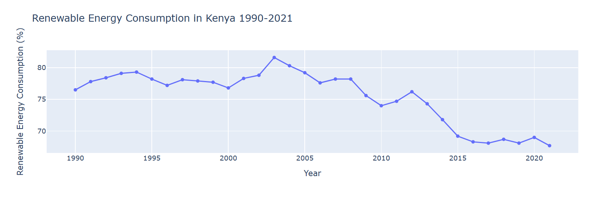

Figure : Kenya's REC 1990-2021

Kenya's renewable energy consumption (REC) as a percentage of total energy consumption has followed an interesting trajectory. REC peaked at around 81% in the early 2000s, but has since stabilized at a level of 65-75%.

This suggests that while Kenya has historically been a leader in renewable energy use, it has not been able to sustain the same high levels in more recent years. The country's reliance on hydropower and geothermal energy sources presents opportunities for further diversification into other renewable technologies like solar and wind.

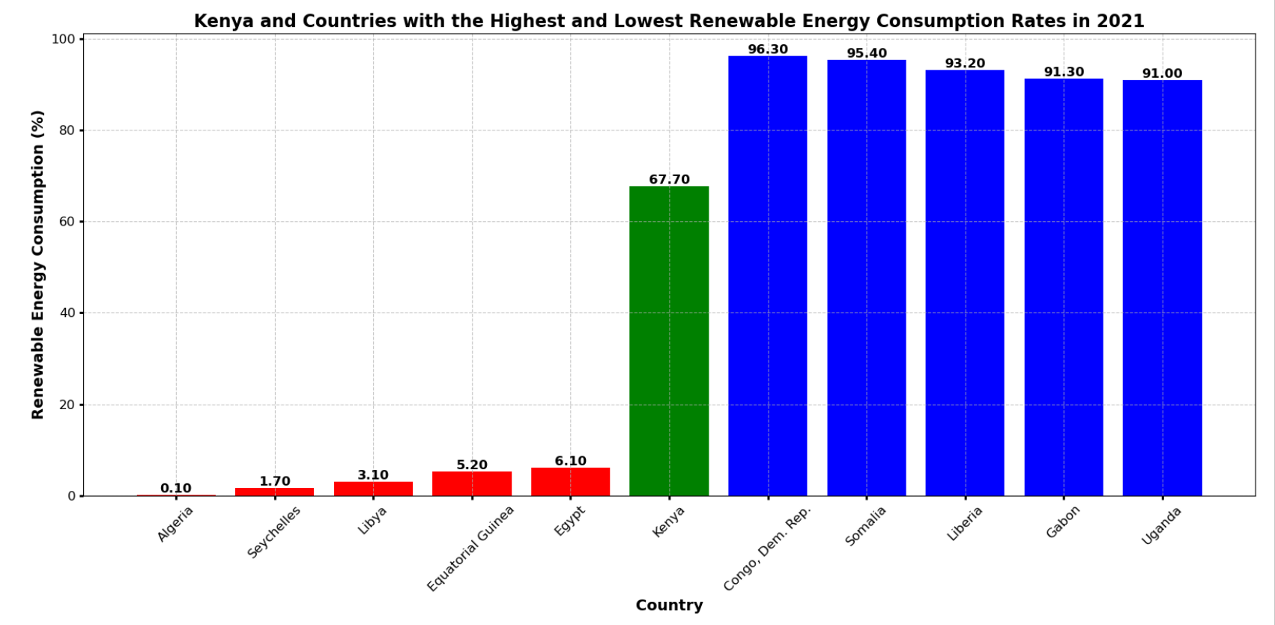

Figure : REC Rates for Kenya and Countries with the Highest and Lowest Rates in 2021

The analysis reveals stark contrasts in renewable energy consumption across African nations. Kenya occupies a distinctive middle ground, with a 67.7% renewable energy consumption (REC) that surpasses low-performing oil-dependent countries like Algeria and Libya, yet falls short of the over 90% REC achieved by the Democratic Republic of the Congo, Somalia, and Liberia.

These regional variations reflect complex interactions between natural resources, economic structures, and policy environments. Countries with abundant hydropower or biomass resources can more readily develop renewable energy infrastructure. Conversely, oil-producing nations face economic and infrastructural barriers to transitioning away from fossil fuel-based energy systems.

Kenya exemplifies the potential for strategic renewable energy development in a middle-income African context. Its notable 67.7% REC results from targeted policies and strategic investment in geothermal resources, positioning it as a promising model for sustainable energy transformation.

However, caution is necessary when interpreting renewable energy statistics. High percentages can be misleading, often inflated by traditional biomass use in rural areas rather than representing advanced green technologies. This nuance is crucial for accurately assessing a country's true renewable energy landscape and progress.

The data underscores the multifaceted challenges and opportunities in Africa's energy transition, highlighting the need for tailored approaches that consider each nation's unique environmental, economic, and technological contexts.

# Discussion

## Analysis of Findings

***Varied Renewable Energy Adoption****:* There is a significant disparity in REC (% of total energy consumption) across African countries. While some nations like Congo Dem. Rep., Uganda, and Ethiopia consistently show high percentages (close to 100%), others such as Algeria, Libya, and Egypt have very low adoption rates (below 20%).

***Overall Declining Trend****:* Despite individual success stories, the average REC (% of total energy consumption)  across African countries shows a declining trend from 1990 to 2020, with a simple average growth rate of -0.62%.

***Investment and Renewable Energy Relationship****:* There is a weak positive correlation between Foreign Direct Investment (FDI) as a percentage of GDP and REC (% of total energy consumption), suggesting that increased investment doesn't necessarily translate directly to higher renewable energy adoption.

***SDG 7 Progress****:* Progress towards SDG 7 (Affordable and Clean Energy) varies widely across the continent. Countries like Gabon and South Africa lead in composite scores for SDG 7 indicators, while others like South Sudan lag significantly behind.

***Economic Impact****:* The relationship between REC (% of total energy consumption) and GDP growth is weak, indicating that other factors likely have more significant impacts on economic growth in African countries.

***Regional Clusters****:* African countries can be grouped into distinct clusters based on their REC (% of total energy consumption) patterns and growth rates, suggesting opportunities for targeted regional cooperation and knowledge sharing.

## Comparison to Literature

The findings align with global research suggesting that renewable energy adoption alone does not directly translate to economic growth. However, the potential for job creation, energy security, and environmental benefits make renewable energy a critical component of sustainable development.

## Limitations

This study is limited by the availability of data for certain African countries, particularly in the early years of the study period. Additionally, the analysis focuses on aggregate measures of REC (% of total energy consumption) and does not account for differences in energy mix or infrastructure quality.

## Summary of Key Findings

Africa’s renewable energy transition has progressed unevenly, with countries like Zimbabwe, Gabon, and Eswatini demonstrating significant growth in REC (% of total energy consumption). Economic growth remains weakly correlated with REC (% of total energy consumption), but FDI plays a critical role in driving GDP growth.

## Contribution to Knowledge

This report contributes to the understanding of Africa’s energy transition by identifying key investment opportunities and highlighting the importance of regional cooperation. The findings also provide insights into the role of renewable energy in achieving SDG 7.

# Recommendations

## Short-term Actions

1. ***Targeted Investment Promotion****:* Develop country-specific investment promotion strategies focusing on countries with high growth potential in renewable energy, such as Zimbabwe, Gabon, and Congo, Rep.
2. ***Tailored Investment Strategies****:* Develop country-specific investment strategies that account for the unique renewable energy landscape and growth potential of each nation.
3. ***Policy Benchmarking****:* Conduct a comprehensive policy review, benchmarking successful regulatory frameworks from top-performing countries like Gabon and Zimbabwe. Implement best practices in countries lagging in renewable energy adoption.
4. ***Policy Framework Enhancement****:* Strengthen policy frameworks to support renewable energy adoption, focusing on successful models from high-performing countries like Gabon and Zimbabwe.
5. ***Capacity Building****:* Initiate capacity-building programs focusing on renewable energy technology, project management, and policy implementation. Prioritize countries with high potential but low current capacity.
6. ***Data Improvement****:* Enhance data collection and reporting mechanisms across African countries to ensure more accurate and timely renewable energy statistics. This will support better decision-making and progress tracking.

## Long-term Strategies

1. ***Regional Integration****:* Develop long-term plans for regional power pools and cross-border renewable energy projects, leveraging the strengths of different countries within identified clusters.
2. ***Regional Cooperation***: Establish and strengthen regional cooperation frameworks based on identified clusters, facilitating knowledge sharing and cross-border renewable energy initiatives.
3. ***Economic Integration****:* Develop strategies to better integrate renewable energy adoption with broader economic development goals, recognizing the complex relationship between energy transitions and economic growth.
4. ***Technology Transfer****:* Establish continent-wide programs for technology transfer and knowledge sharing, focusing on adapting successful renewable energy technologies to local contexts.
5. ***Education and Workforce Development****:* Invest in long-term education and training programs to build a skilled workforce capable of supporting a growing renewable energy sector across Africa.
6. ***Research and Innovation****:* Create a pan-African renewable energy research network to foster innovation and develop technologies suited to Africa's unique energy challenges.

## Investment Priorities

1. ***Grid Infrastructure***: Prioritize investments in grid infrastructure to support increased renewable energy integration, focusing on countries with high renewable potential but poor distribution networks.
2. ***Off-grid and Mini-grid Solutions****:* Invest in off-grid and mini-grid renewable energy solutions for remote and rural areas, particularly in countries with low electricity access rates.
3. ***Energy Storage****:* Support the development and deployment of energy storage technologies to address the intermittency challenges of renewable energy sources.
4. ***Renewable Resource Mapping****:* Invest in comprehensive renewable resource mapping across Africa to identify high-potential areas for solar, wind, geothermal, and hydroelectric projects.

## Policy Suggestions

1. ***Harmonized Renewable Energy Targets***: Encourage all African countries to set and regularly update ambitious, yet achievable renewable energy targets aligned with the Paris Agreement and SDG 7.
2. ***SDG 7 Alignment****:* Intensify efforts to align national energy strategies with SDG 7 targets, particularly in countries lagging behind in clean energy access and renewable capacity.
3. ***Standardized Power Purchase Agreements (PPAs)****:* Develop standardized PPAs for renewable energy projects to reduce transaction costs and attract more private investment.
4. ***Green Finance Mechanisms****:* Establish national and regional green finance mechanisms to channel funding towards renewable energy projects, including green bonds and climate finance instruments.
5. ***Fossil Fuel Subsidy Reform****:* Gradually phase out fossil fuel subsidies while implementing social protection measures to cushion the impact on vulnerable populations. Redirect savings towards renewable energy development.
6. ***Local Content Policies****:* Implement balanced local content policies that promote the development of domestic renewable energy industries while still attracting foreign investment and expertise.
7. ***Cross-border Energy Trade***: Develop policies and regulatory frameworks to facilitate cross-border renewable energy trade, leveraging the strengths of different regions and promoting energy security.

By implementing these recommendations, African countries can accelerate their transition to sustainable energy, capitalize on investment opportunities, and make significant progress towards achieving SDG 7 while fostering economic growth and regional cooperation.

# Glossary of Technical Terms

**A**

**API (Application Programming Interface)**: A set of protocols and tools for building software applications, used here for accessing the UN SDG Indicators Database.

**C**

**CAGR (Compound Annual Growth Rate)**: A measure of growth over multiple periods, calculated as if the growth had happened steadily each year over a specified time.

**Cluster Analysis**: A statistical method used to group similar objects into clusters, applied here to group countries with similar renewable energy adoption patterns.

**Correlation Analysis**: A statistical method used to measure the strength and direction of relationships between variables.

**D**

**Descriptive Statistics**: Statistical methods used to summarize and describe the basic features of a dataset.

**E**

**EDA (Exploratory Data Analysis)**: An approach to analyzing data sets to summarize their main characteristics, often with visual methods.

**Energy Intensity**: The amount of energy used to produce a unit of economic output, measured here in mega joules per constant 2017 purchasing power parity GDP.

**Energy Transition Model**: A theoretical framework describing the shift from fossil fuels to renewable energy sources as a pathway to sustainable development.

**F**

**FDI (Foreign Direct Investment)**: An investment made by a firm or individual in one country into business interests located in another country.

**G**

**GDP (Gross Domestic Product)**: The total monetary or market value of all the finished goods and services produced within a country's borders in a specific time.

**M**

**Machine Learning**: A field of artificial intelligence that uses statistical techniques to give computer systems the ability to "learn" from data.

**O**

**OLS (Ordinary Least Squares) Regression**: A type of linear least squares method for estimating the unknown parameters in a linear regression model.

**P**

**PPP (Purchasing Power Parity)**: A measurement of prices in different countries that uses the prices of specific goods to compare the absolute purchasing power of the countries' currencies.

**R**

**Regression Analysis**: A set of statistical processes for estimating the relationships between variables.

**Renewable Energy**: Energy from sources that are naturally replenishing but flow-limited, such as biomass, hydro, geothermal, solar, and wind.

**S**

**SDG (Sustainable Development Goal)**: A collection of 17 interlinked global goals designed to be a "blueprint to achieve a better and more sustainable future for all", set up by the United Nations General Assembly.

**SDG 7**: The seventh Sustainable Development Goal, which aims to "Ensure access to affordable, reliable, sustainable and modern energy for all".

**T**

**Time Series Analysis**: A method of analyzing time series data to extract meaningful statistics and other characteristics of the data.

**T-test**: A statistical test used to determine if there is a significant difference between the means of two groups.

# References

BioMed Central. (2021). *The socio-economic impact of renewable energy in Africa*. Retrieved from [https://energsustainsoc.biomedcentral.com/articles/10.1186/s13705-021-00295-4](%20https://energsustainsoc.biomedcentral.com/articles/10.1186/s13705-021-00295-4)

Cherp, A., Vinichenko, V., Tosun, J., Gordon, R., & Jewell, J. (2018). Integrating techno-economic, socio-technical and political perspectives on national energy transitions: A meta-theoretical framework. *Energy Research & Social Science, 37*, 175-190. [https://www.mdpi.com/2071-1050/15/17/12693](%20https://www.mdpi.com/2071-1050/15/17/12693)

FEPBL. (2022). *The role of policy and technology in renewable energy success*. Retrieved from [https://fepbl.com/index.php/estj/article/download/1154/1382](%20https://fepbl.com/index.php/estj/article/download/1154/1382)

Foster, V., & Rana, A. (2020). *Rethinking power sector reform in the developing world*. Sustainable Infrastructure. Washington, DC: World Bank. [https://openknowledge.worldbank.org/handle/10986/32335](%20https://openknowledge.worldbank.org/handle/10986/32335)

International Energy Agency (IEA). (2022). *Africa energy outlook 2022*. Retrieved from <https://www.iea.org/reports/africa-energy-outlook-2022>

International Energy Agency (IEA). (2022a). *Africa Energy Outlook 2022: Key Findings*. Retrieved from <https://www.iea.org/reports/africa-energy-outlook-2022>

International Energy Agency (IEA). (2022b). *Africa Energy Outlook 2022*. Retrieved from [https://www.iea.org/reports/africa-energy-outlook-2022](%20https://www.iea.org/reports/africa-energy-outlook-2022)

International Energy Agency (IEA). (2022c). *Africa Energy Outlook 2022: Regional Cooperation*. Retrieved from <https://www.iea.org/reports/africa-energy-outlook-2022>

International Energy Agency (IEA). (2022d). *Africa Energy Outlook 2022: Challenges and Policy Recommendations*. Retrieved from [https://www.iea.org/reports/africa-energy-outlook-2022](%20https://www.iea.org/reports/africa-energy-outlook-2022)

International Renewable Energy Agency (IRENA). (2023). *World Energy Transitions Outlook 2023*. Retrieved from [https://www.irena.org/Digital-Report/World-Energy-Transitions-Outlook-2023](%20https://www.irena.org/Digital-Report/World-Energy-Transitions-Outlook-2023)

Korea Energy Economics Institute (KEEI). (2023). *Study on Renewable Energy Transition in Developing Nations*. Retrieved from [https://www.keei.re.kr/pdfOpen.es?bid=0028&list_no=119346&seq=1](%20%20https://www.keei.re.kr/pdfOpen.es?bid=0028&list_no=119346&seq=1)

Ministry of Energy Kenya. (2023). *Kenya Energy Transition Implementation Plan 2050*. Retrieved from [https://energy.go.ke/sites/default/files/KAWI/Kenya-ETIP-2050%202.pdf](%20https://energy.go.ke/sites/default/files/KAWI/Kenya-ETIP-2050%202.pdf)

Moyo, A., & Billon, P. (2021). *The economic implications of renewable energy projects in Africa: Policy gaps and the way forward*. *African Economic Review, 6*(2), 15-33. Retrieved from  [https://fepbl.com/index.php/estj/article/view/1154](%20%20https://fepbl.com/index.php/estj/article/view/1154)

MDPI. (2023). *Institutional capacity and renewable energy outcomes in developing regions*. Retrieved from [https://www.mdpi.com/1996-1073/16/18/6682](%20https://www.mdpi.com/1996-1073/16/18/6682)

Oxford Reference. (2021). *Resource-Based View in Economic Development*. Retrieved from [https://oxfordre.com/business/display/10.1093/acrefore/9780190224851.001.0001/acrefore-9780190224851-e-4?d=%2F10.1093%2Facrefore%2F9780190224851.001.0001%2Facrefore-9780190224851-e-4](%20%20%20https://oxfordre.com/business/display/10.1093/acrefore/9780190224851.001.0001/acrefore-9780190224851-e-4?d=%2F10.1093%2Facrefore%2F9780190224851.001.0001%2Facrefore-9780190224851-e-4)

Renewable Energy Policy Network for the 21st Century (REN21). (2021a). *Renewables 2021 Global Status Report: Executive Summary*. Retrieved from [https://ren21.net/gsr-2021/](%20https://ren21.net/gsr-2021/)

Renewable Energy Policy Network for the 21st Century (REN21). (2021b). *Renewables 2021 Global Status Report*. Retrieved from [https://ren21.net/gsr-2021/](%20https://ren21.net/gsr-2021/)

Renewable Energy Policy Network for the 21st Century (REN21). (2021c). *Renewables 2021 Global Status Report: COVID-19 Impacts*. Retrieved from [https://ren21.net/gsr-2021/](%20https://ren21.net/gsr-2021/)

Renewable Energy Policy Network for the 21st Century (REN21). (2021d). *Renewables 2021 Global Status Report: African Renewable Potential*. Retrieved from [https://ren21.net/gsr-2021/](%20%20https://ren21.net/gsr-2021/)

Renewable Energy Policy Network for the 21st Century (REN21). (2021e). *Renewables 2021 Global Status Report: Policy Recommendations for Africa*. Retrieved from [https://ren21.net/gsr-2021/](%20https://ren21.net/gsr-2021/)

Renewable Energy Policy Network for the 21st Century (REN21). (2021f). *Renewables 2021 Global Status Report: Economic Recovery Recommendations*. Retrieved from [https://ren21.net/gsr-2021/](%20https://ren21.net/gsr-2021/)

Renewable Energy Policy Network for the 21st Century (REN21). (2021g). *Renewables 2021 Global Status Report: International Cooperation and Investment*. Retrieved from [https://ren21.net/gsr-2021/](%20%20https://ren21.net/gsr-2021/)

ScienceDirect. (2021). *Resource-Based View and VRIN Criteria*. Retrieved from [https://www.sciencedirect.com/topics/economics-econometrics-and-finance/resource-based-view](%20%20https://www.sciencedirect.com/topics/economics-econometrics-and-finance/resource-based-view)

Study.com. (2021). *Resource-Based Theory: Path to Competitive Advantage*. Retrieved from [https://study.com/academy/lesson/resource-based-theory-path-to-competitive-advantage.html](%20%20https://study.com/academy/lesson/resource-based-theory-path-to-competitive-advantage.html)

United Nations Development Programme (UNDP). (2023). *Energy Transition in Developing Regions: Policy Recommendations*. Retrieved from [https://www.undp.org/sites/g/files/zskgke326/files/publications/chapter12.pdf](%20%20https://www.undp.org/sites/g/files/zskgke326/files/publications/chapter12.pdf)

  University of Illinois. (2021). *Resource-Based View in Economic Development and Job Creation*. Retrieved from [https://www.ideals.illinois.edu/items/30266/bitstreams/101276/data.pdf](%20https://www.ideals.illinois.edu/items/30266/bitstreams/101276/data.pdf)

Wikipedia. (2021). *Resource-Based View*. Retrieved from [https://en.wikipedia.org/wiki/Resource-based_view](%20%20https://en.wikipedia.org/wiki/Resource-based_view)

# Appendices

## Appendix A: Summary of data tables used in the analysis.

Appendix

**Table 1a.**

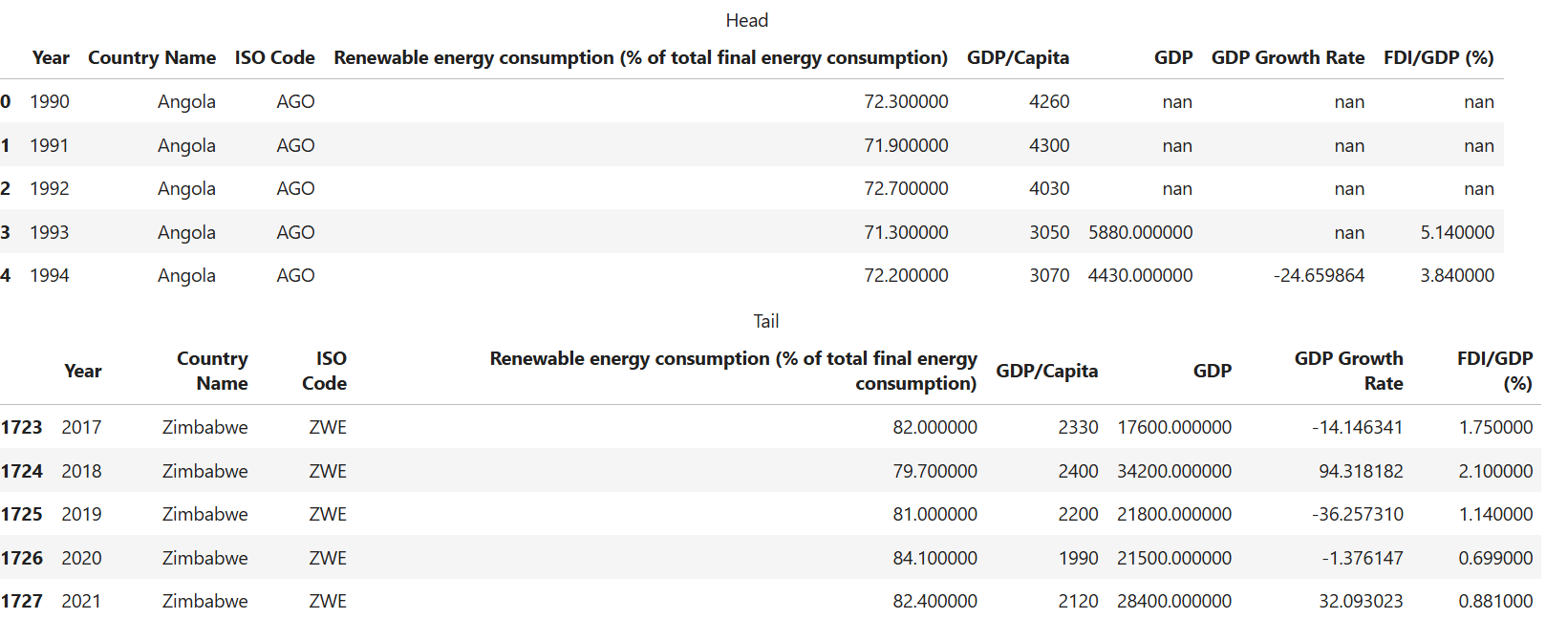

**Table 1b.**

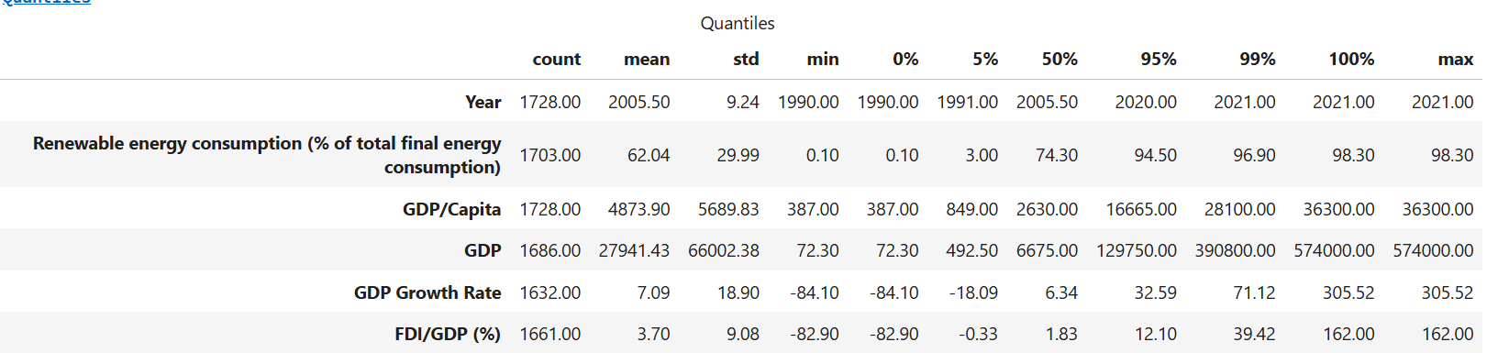

**Table 2a.**

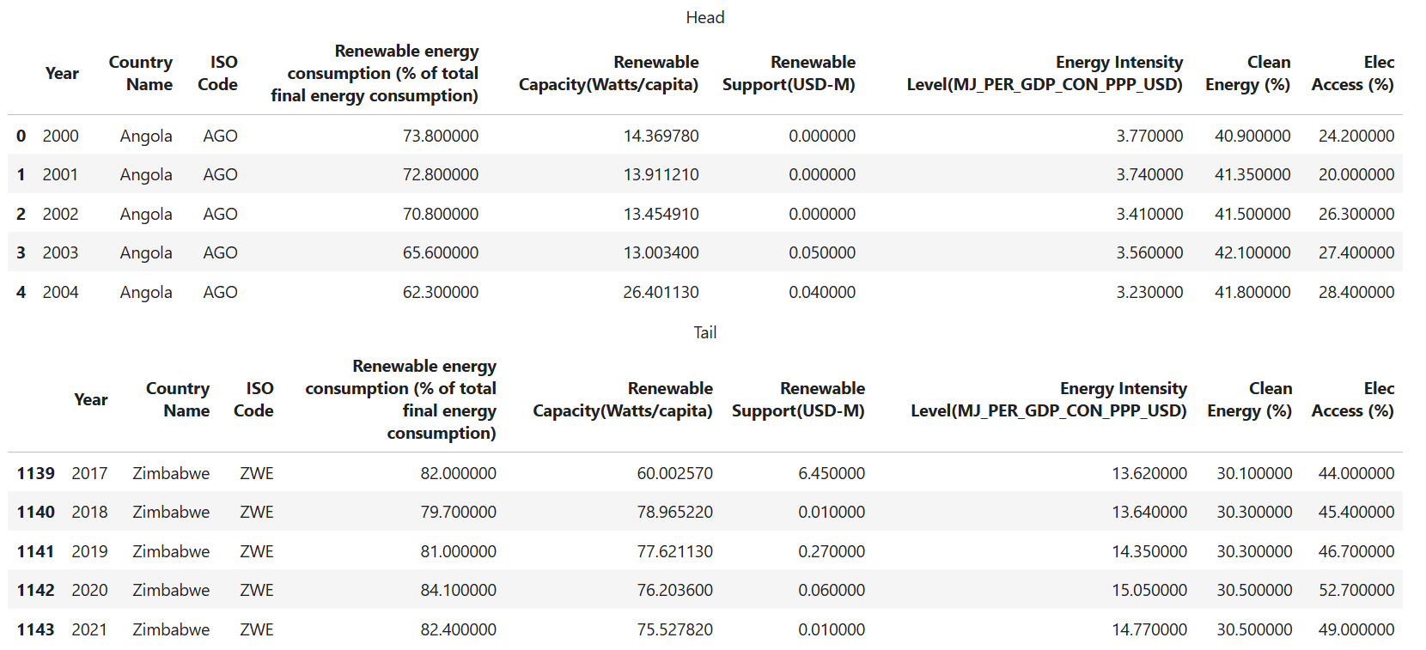

**Table 2b.**

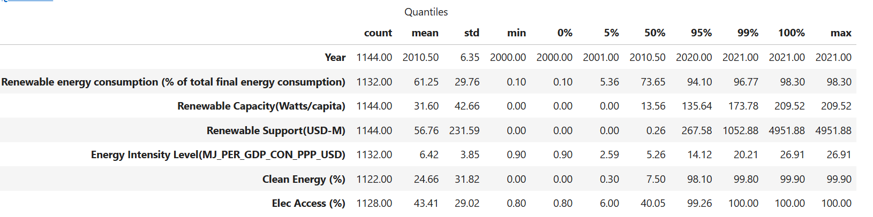

**Table 3a.**

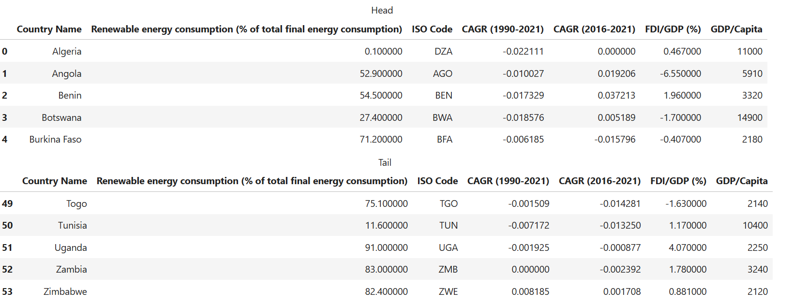

**Table 3b.**

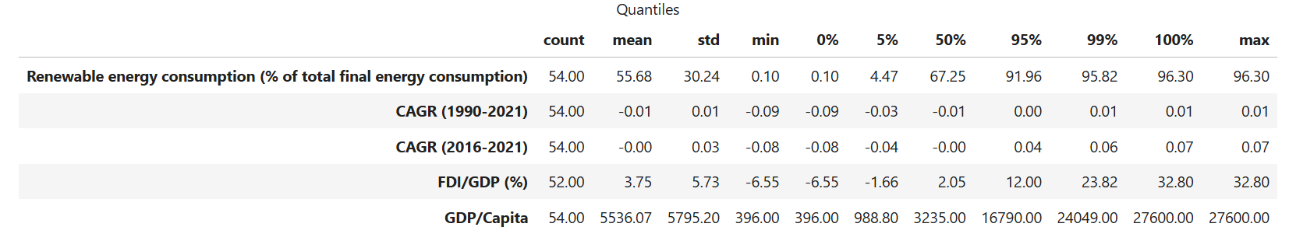

## Appendix B: Charts of REC trends for each African country.

Appendix

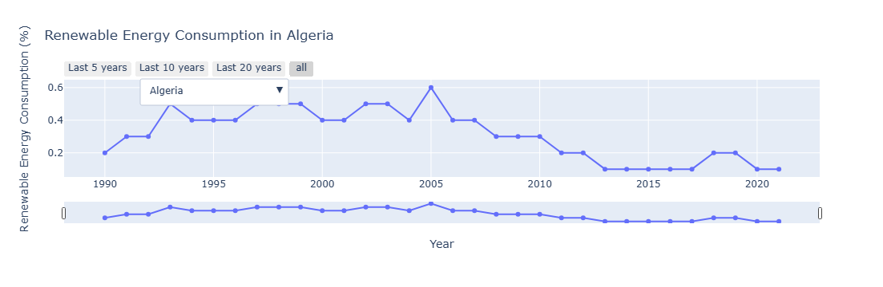

REC Trend : Algeria

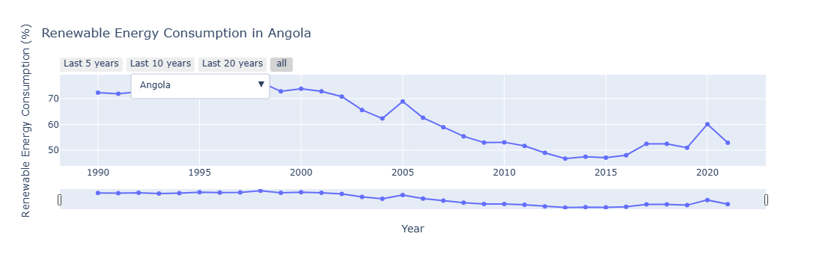

REC Trend : Angola

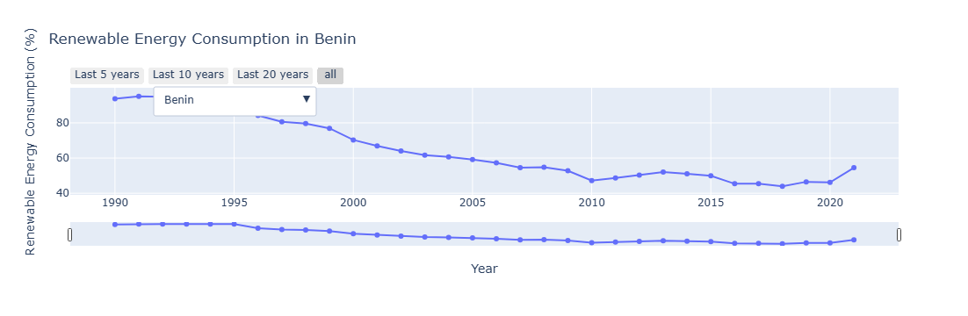

REC Trend : Benin

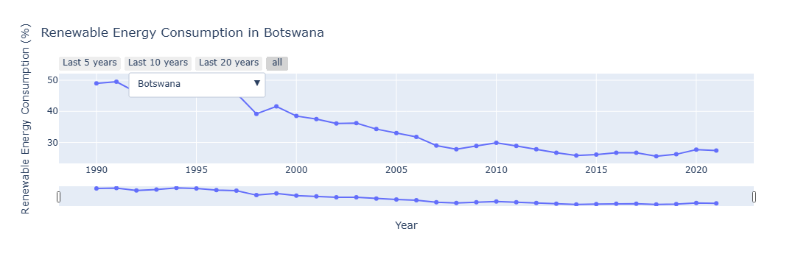

REC Trend : Botswana

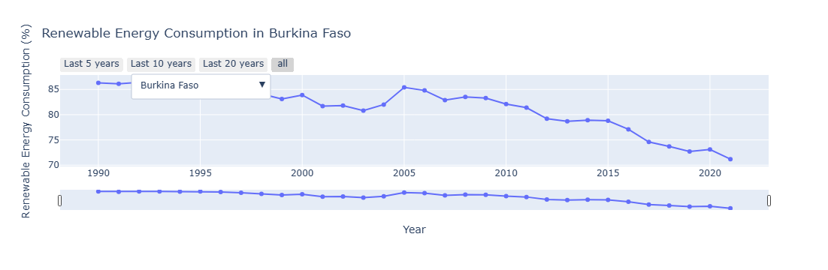

REC Trend : Burkina Faso

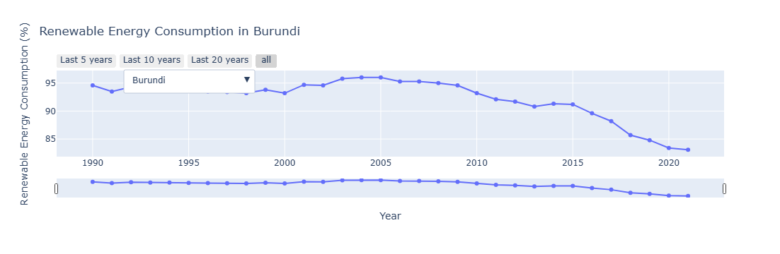

REC Trend : Burundi

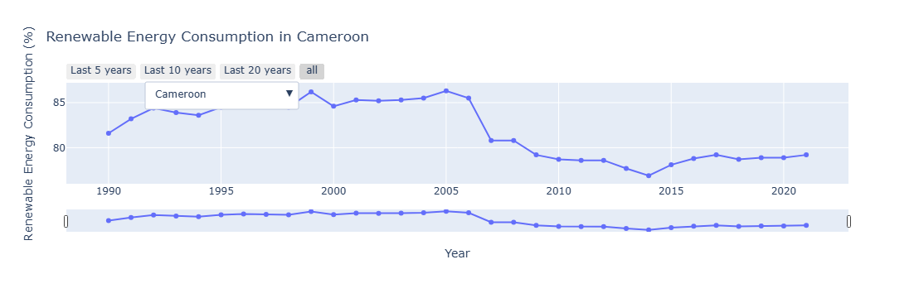

REC Trend : Cameroon

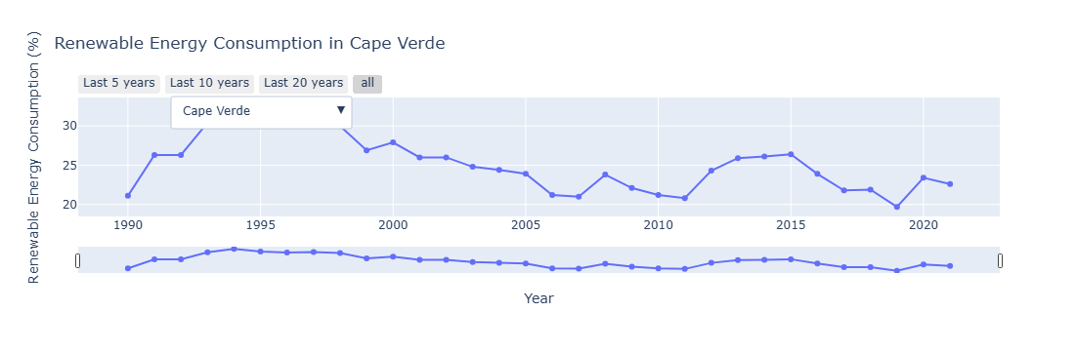

REC Trend ; Cape Verde

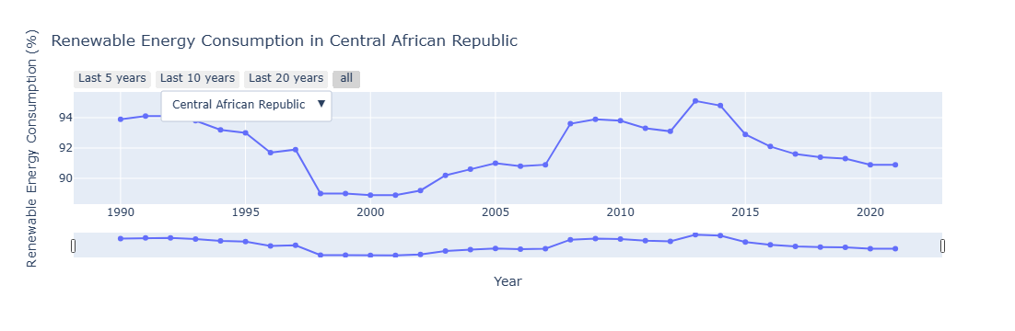

REC Trend : Central African Republic

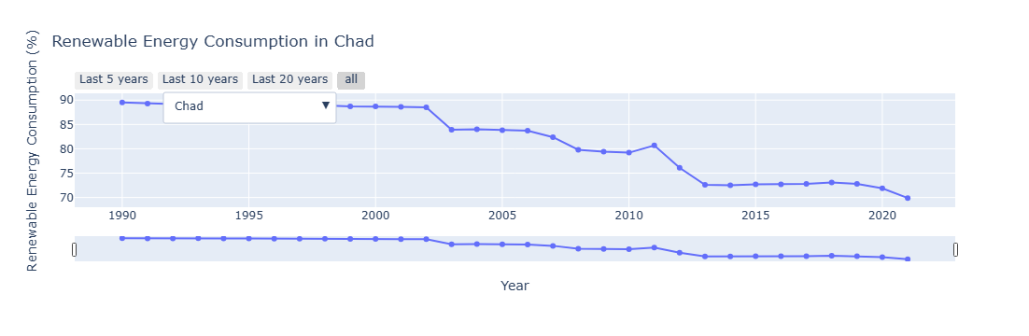

REC Trend : Chad

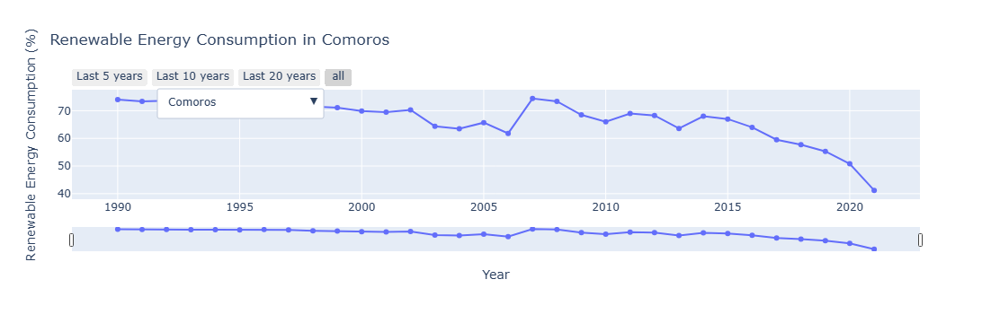

REC Trend : Comoros

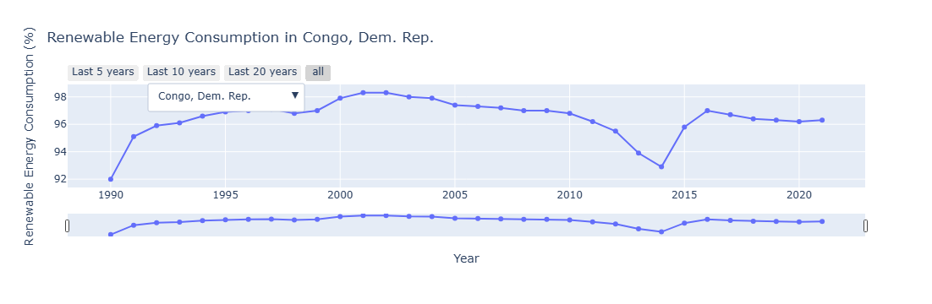

REC Trend : Congo, Dem. Rep.

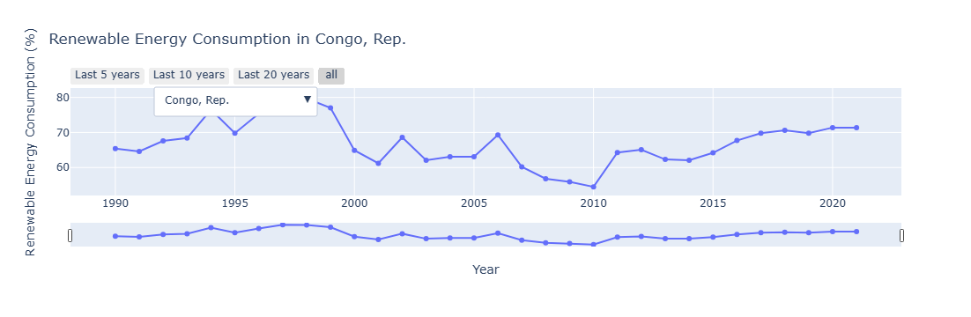

REC Trend : Congo Rep.

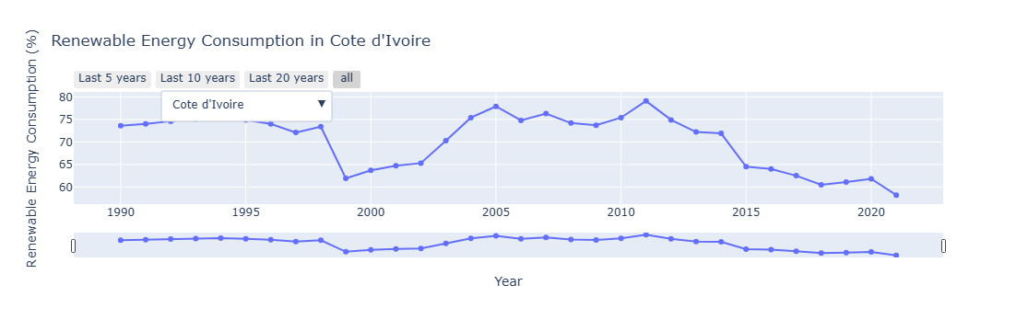

REC Trend : Cote d'Ivoire

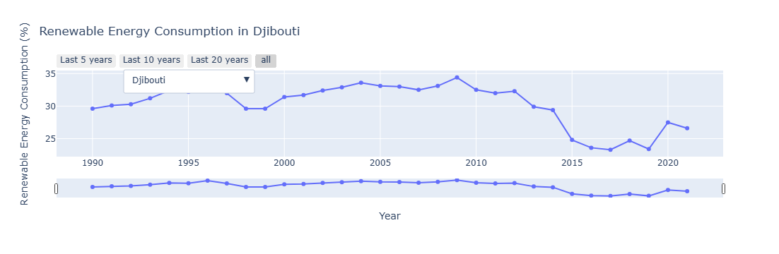

REC Trend : Djibouti

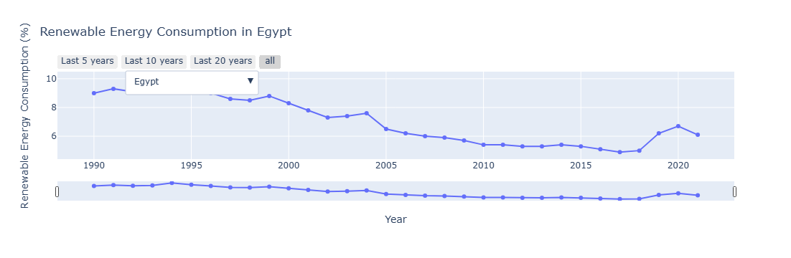

REC Trend : Egypt

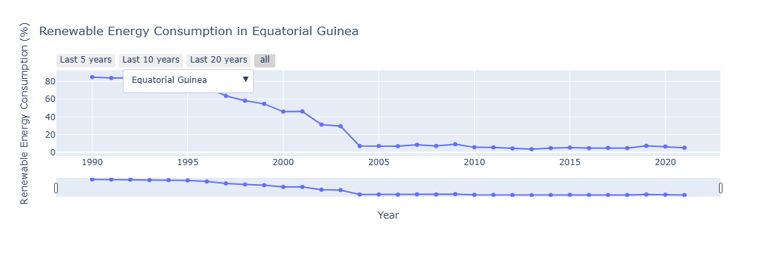

REC Trend : Equatorial Guinea

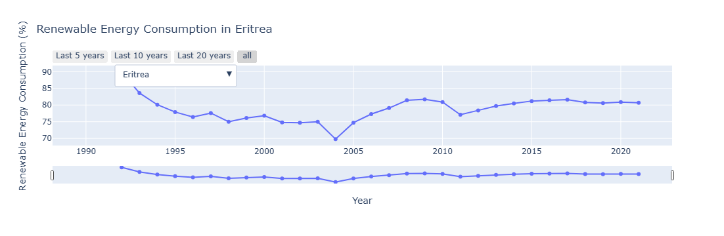

REC Trend : Eritrea

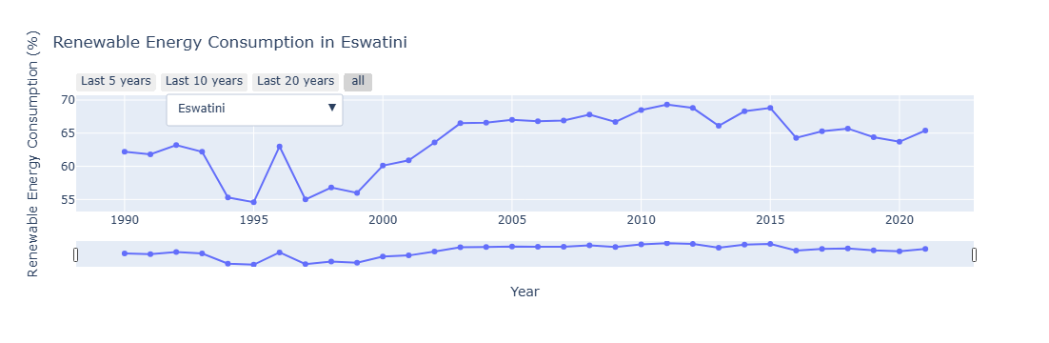

REC Trend : Eswatini

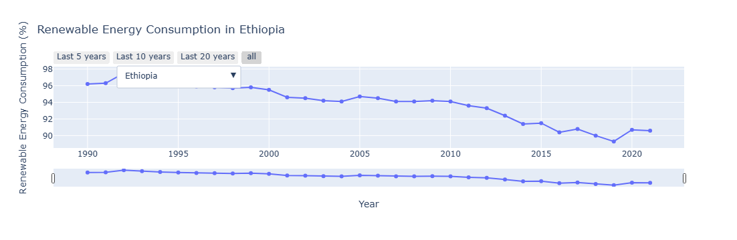

REC Trend : Ethiopia

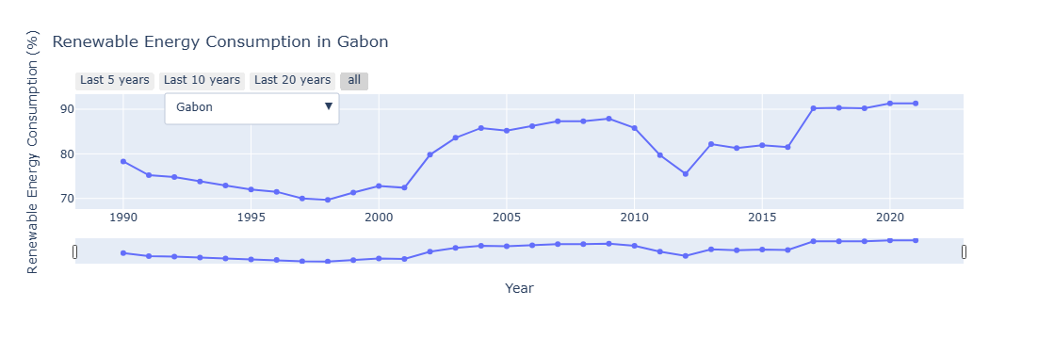

REC Trend : Gabon

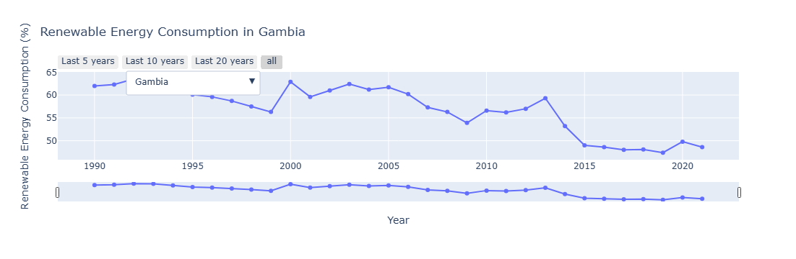

REC Trend : Gambia

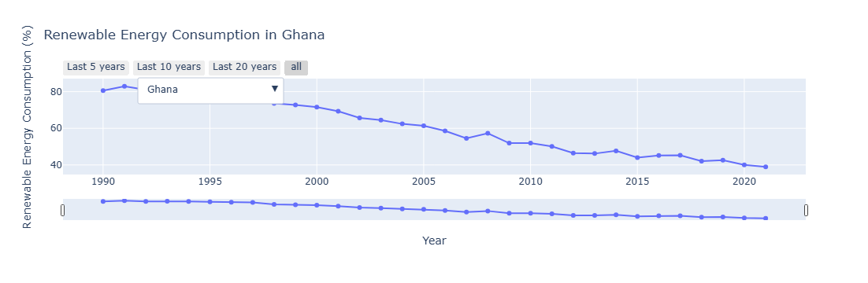

REC Trend : Ghana

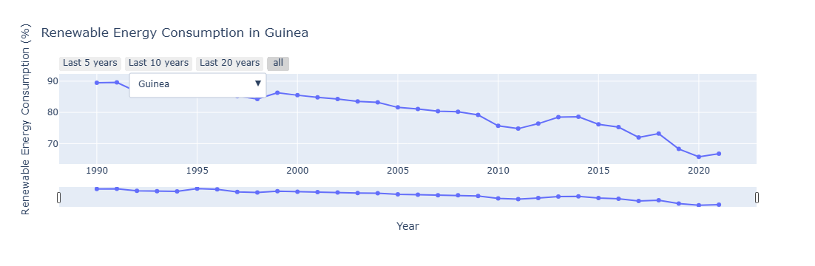

REC Trend : Guinea

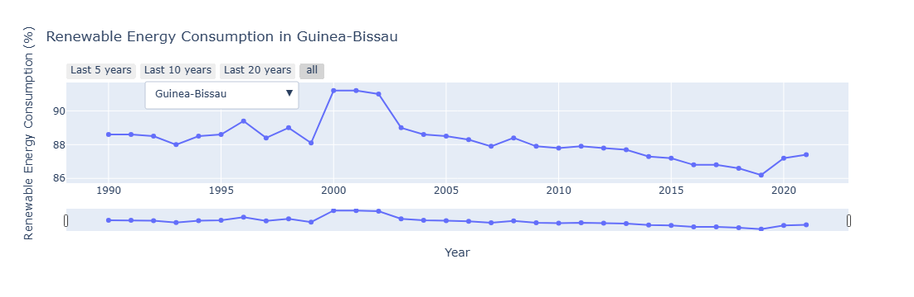

REC Trend : Guinea Bissau

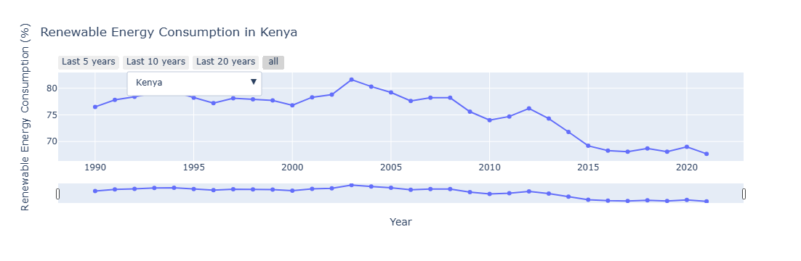

REC Trend : Kenya

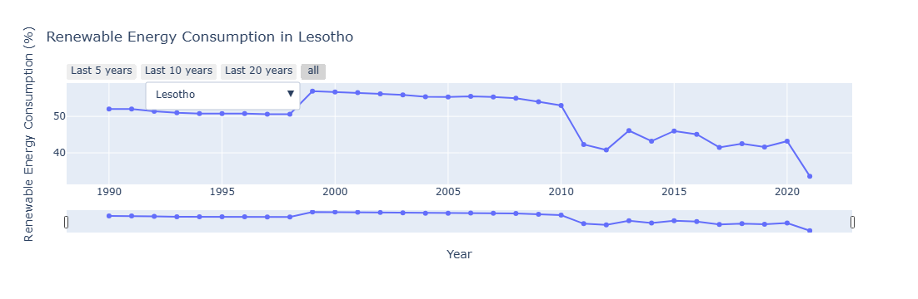

REC Trend : Lesotho

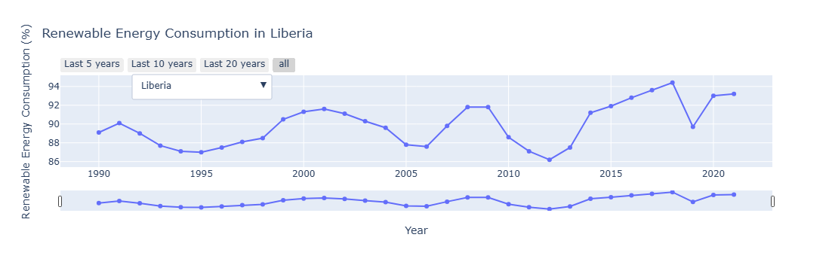

REC Trend : Liberia

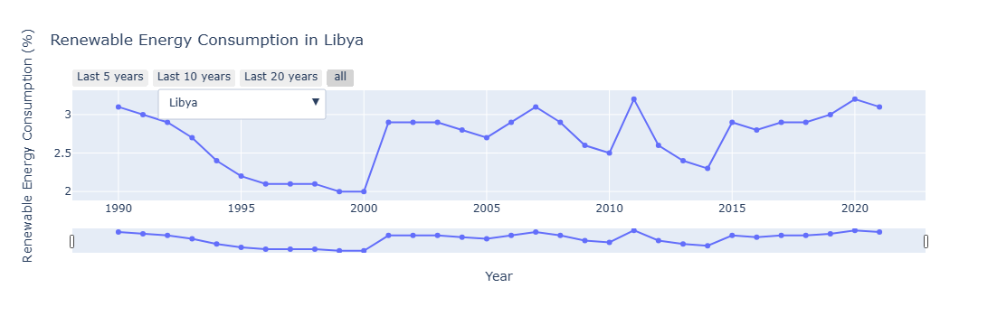

REC Trend : Libya

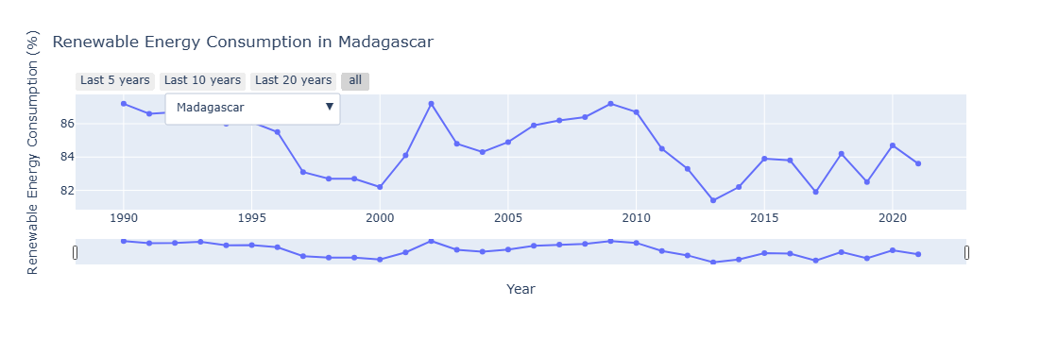

REC Trend : Madagascar

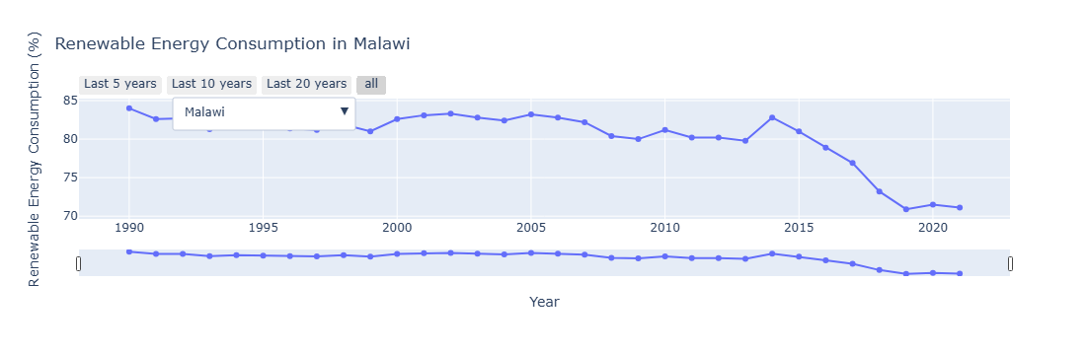

REC Trend : Malawi

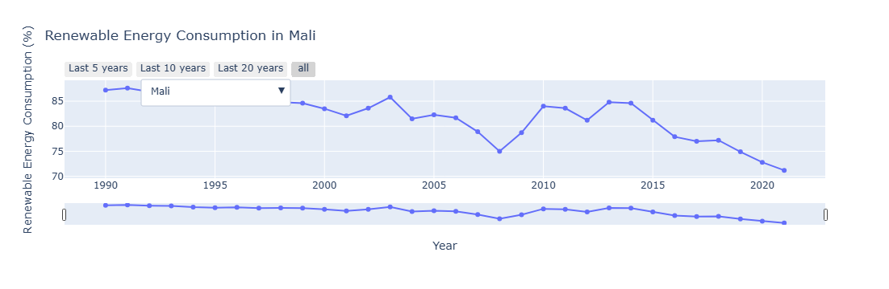

REC Trend : Mali

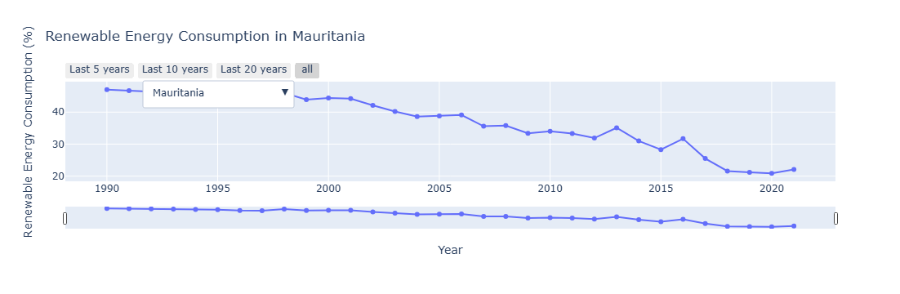

REC Trend : Mauritania

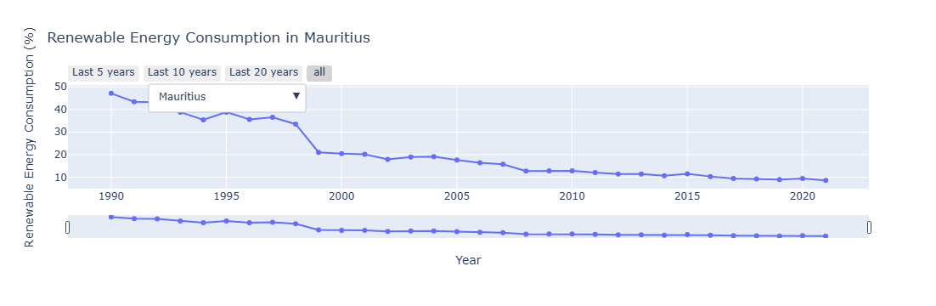

REC Trend : Mauritius

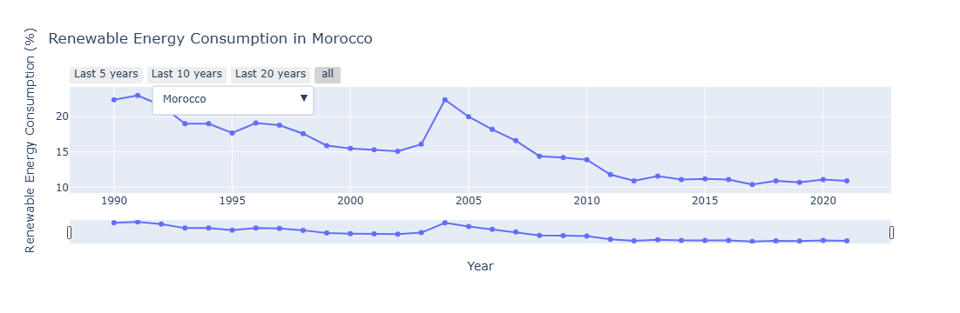

REC Trend : Morocco

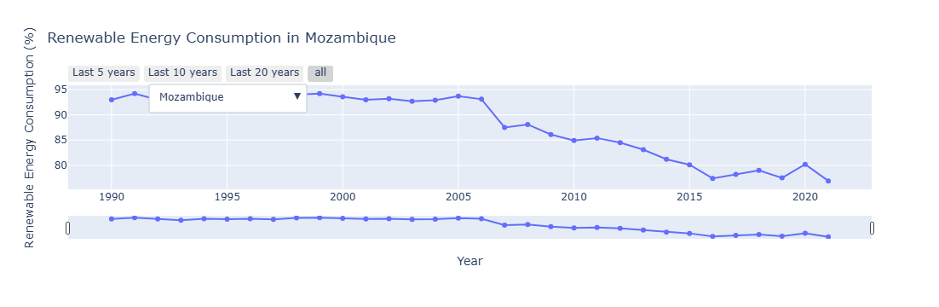

REC Trend : Mozambique

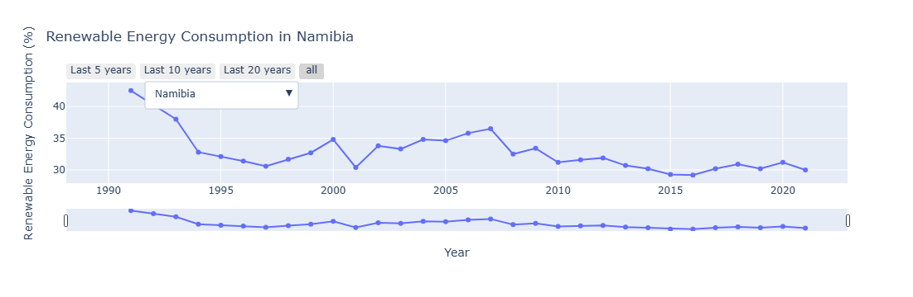

REC Trend : Namibia

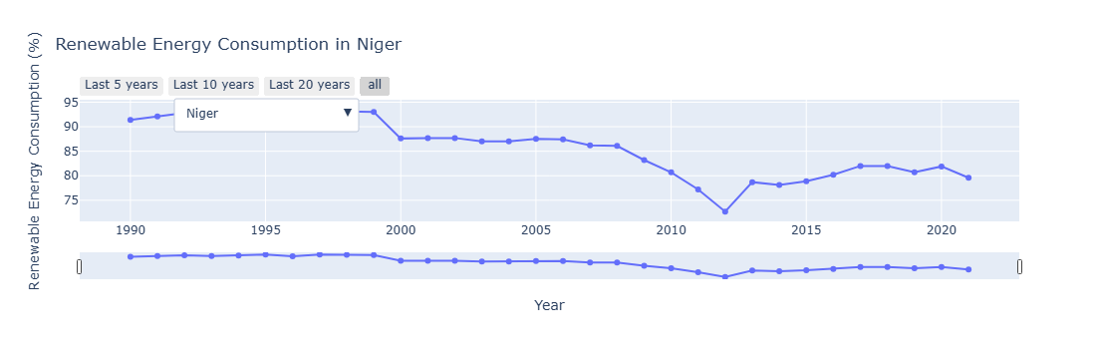

REC Trend : Niger

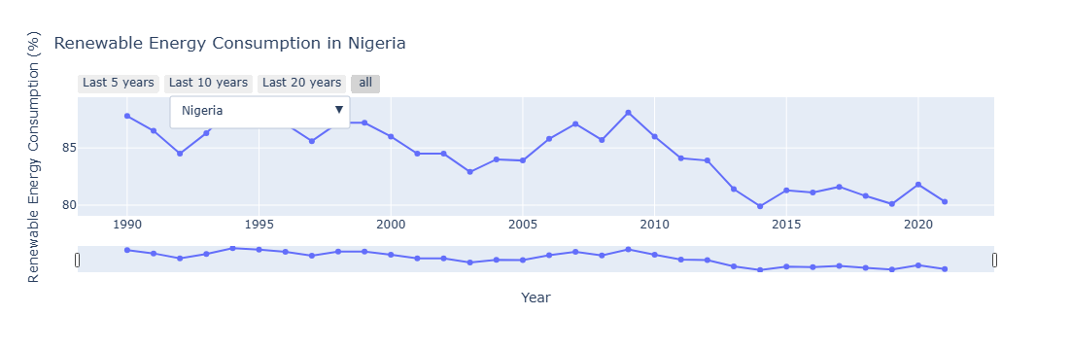

REC Trend : Nigeria

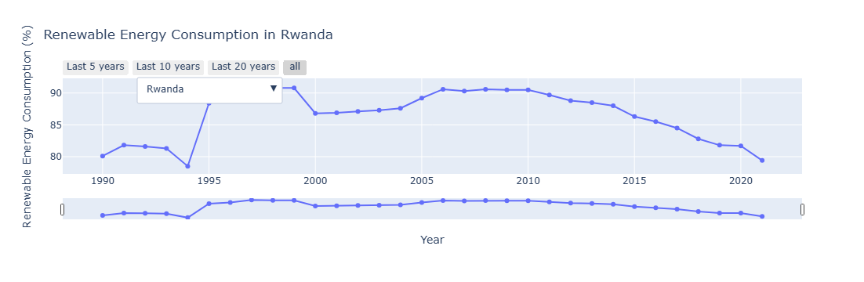

REC Trend : Rwanda

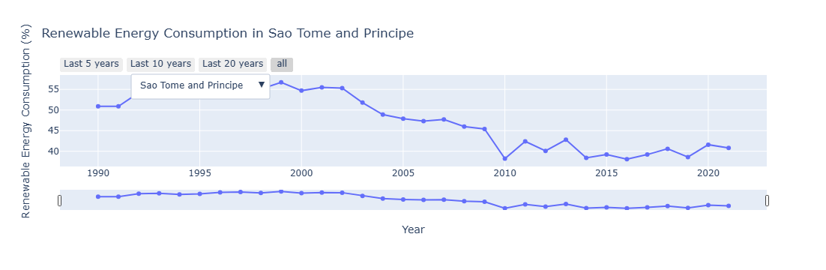

REC Trend : Sao Tome and Principe

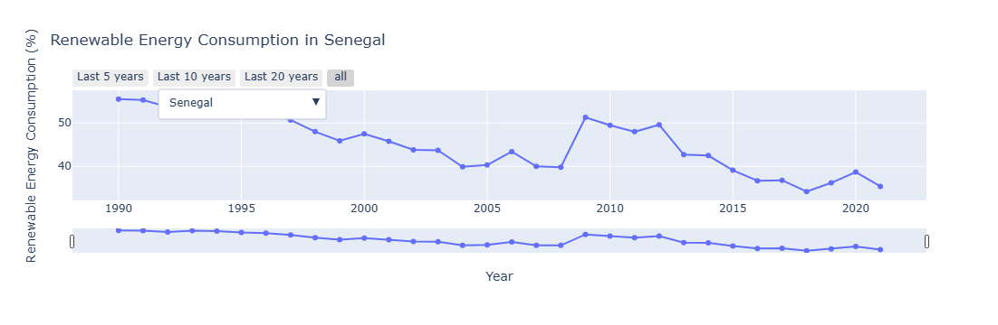

REC Trend : Senegal

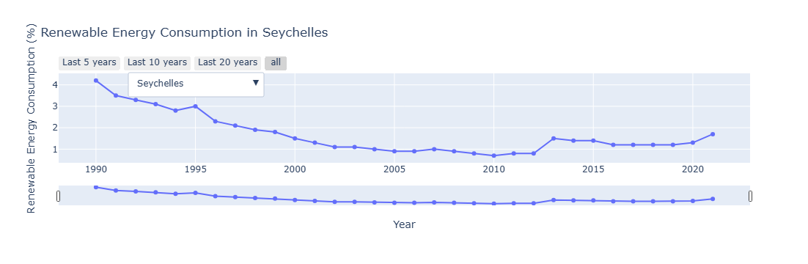

REC Trend : Seychelles

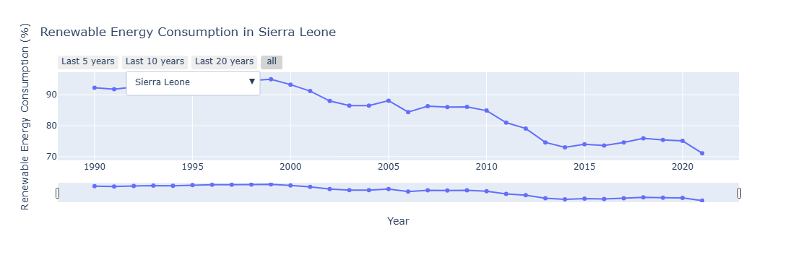

REC Trend : Sierra Leone

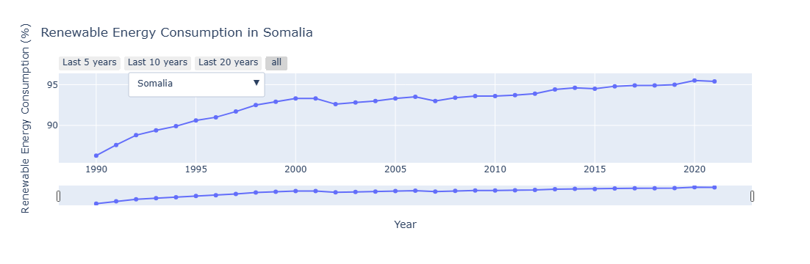

REC Trend : Somalia

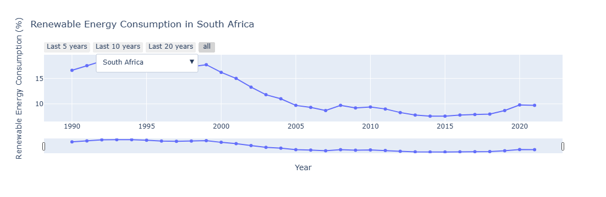

REC Trend : South Africa

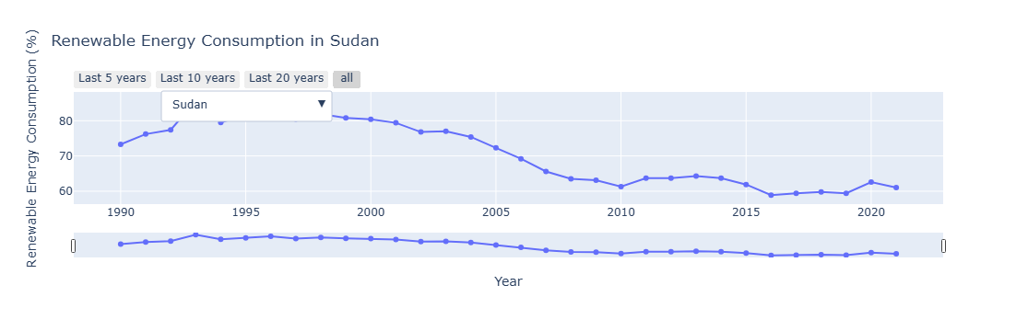

REC Trend : Sudan

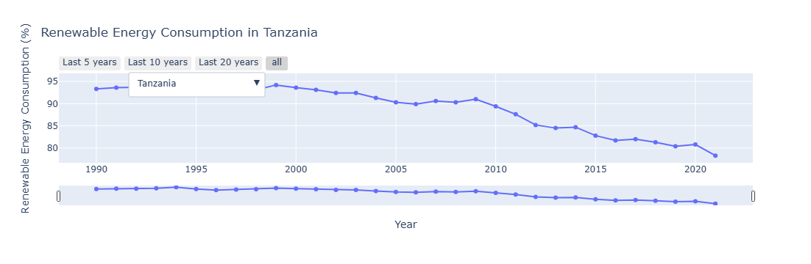

REC Trend : Tanzania

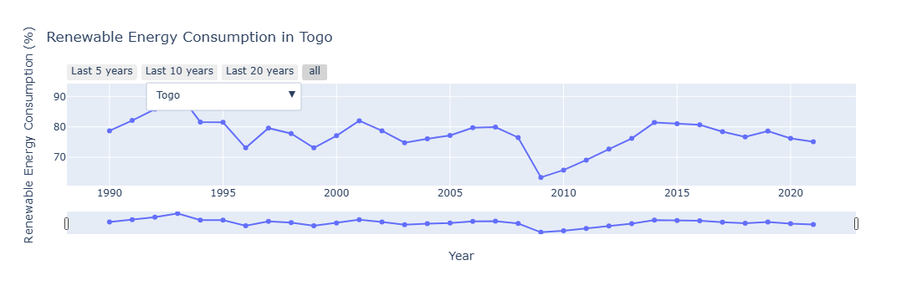

REC Trend : Togo

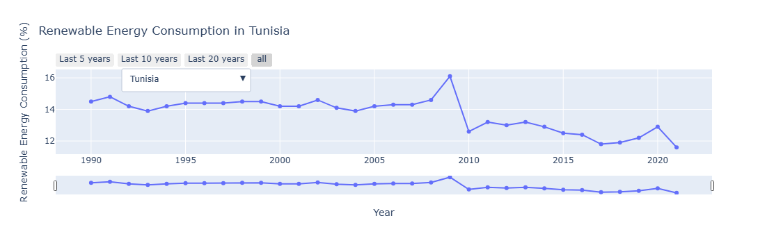

REC Trend : Tunisia

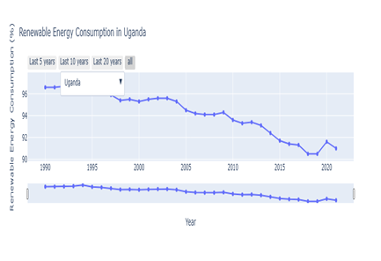

REC Trend : Uganda

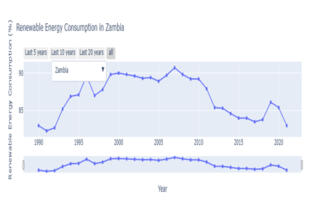

REC Trend : Zambia

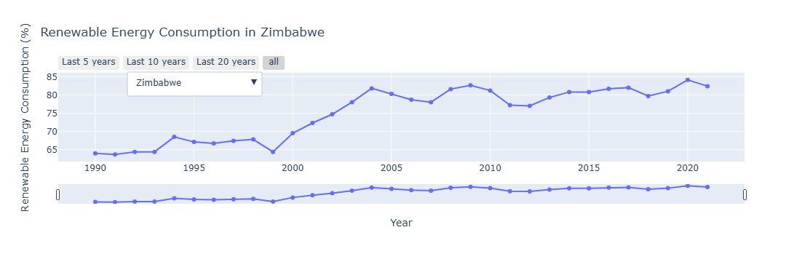

REC Trend : Zimbabwe

## Appendix C: REC CAGR across Countries 1990-2021

Appendix

|  |  |
| --- | --- |
| *COUNTRY* | *CAGR(1990-2021)* |
| *Zimbabwe* | *0.008185* |
| *Gabon* | *0.004967* |
| *Somalia* | *0.003239* |
| *Congo, Rep.* | *0.002835* |
| *Cape Verde* | *0.002218* |
| *South Sudan* | *0.001846* |
| *Eswatini* | *0.001620* |
| *Congo, Dem. Rep.* | *0.001475* |
| *Liberia* | *0.001452* |
| *Libya* | *0.000000* |
| *Zambia* | *0.000000* |
| *Rwanda* | *-0.000283* |
| *Guinea-Bissau* | *-0.000440* |
| *Cameroon* | *-0.000963* |
| *Central African Republic* | *-0.001047* |
| *Madagascar* | *-0.001359* |
| *Togo* | *-0.001509* |
| *Uganda* | *-0.001925* |
| *Ethiopia* | *-0.001933* |
| *Nigeria* | *-0.002876* |
| *Djibouti* | *-0.003441* |
| *Eritrea* | *-0.003477* |
| *Kenya* | *-0.003934* |
| *Burundi* | *-0.004172* |
| *Niger* | *-0.004449* |
| *Malawi* | *-0.005364* |
| *Tanzania* | *-0.005638* |
| *COUNTRY* | ***CAGR(1990-2021)*** |
| *Sudan* | *-0.005908* |
| *Mozambique* | *-0.006113* |
| *Burkina Faso* | *-0.006185* |
| *Mali* | *-0.006518* |
| *Sao Tome and Principe* | *-0.007109* |
| *Tunisia* | *-0.007172* |
| *Cote d'Ivoire* | *-0.007544* |
| *Gambia* | *-0.007824* |
| *Chad* | *-0.007942* |
| *Sierra Leone* | *-0.008383* |
| *Guinea* | *-0.009392* |
| *Angola* | *-0.010027* |
| *Namibia* | *-0.011173* |
| *Egypt* | *-0.012468* |
| *Lesotho* | *-0.013989* |
| *Senegal* | *-0.014401* |
| *South Africa* | *-0.017182* |
| *Benin* | *-0.017329* |
| *Botswana* | *-0.018576* |
| *Comoros* | *-0.018714* |
| *Algeria* | *-0.022111* |
| *Morocco* | *-0.022968* |
| *Ghana* | *-0.023145* |
| *Mauritania* | *-0.024047* |
| *Seychelles* | *-0.028754* |
| *Mauritius* | *-0.053378* |
| *Equatorial Guinea* | *-0.086082* |

## Appendix D: Box Plots Comparing SDG 7 Indicators between the Top-performing

## Countries and others in Africa.

Appendix

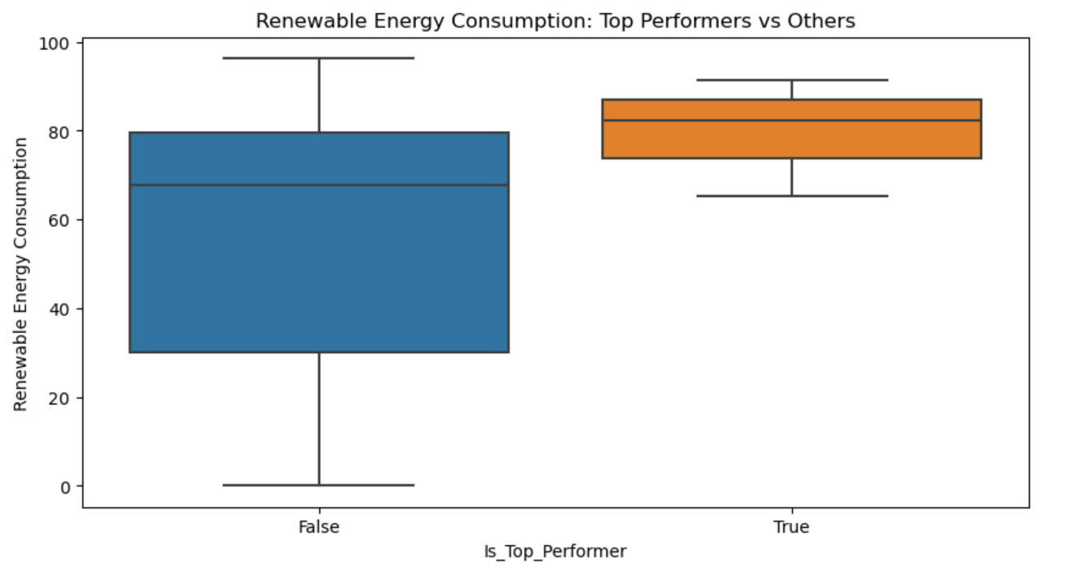

Box plot : REC of Top Performing Countries vs. others.

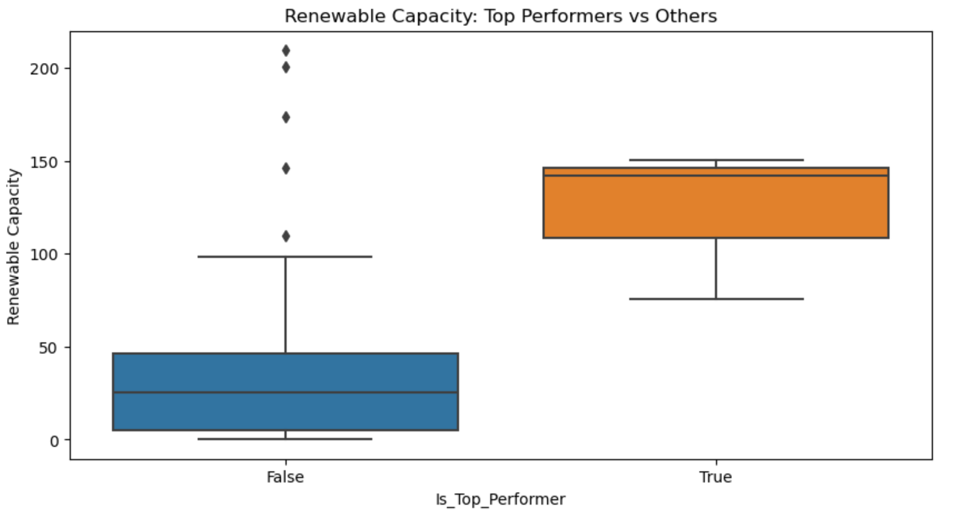

Box plot : Renewable Capacity of Top Performing Countries vs. others.

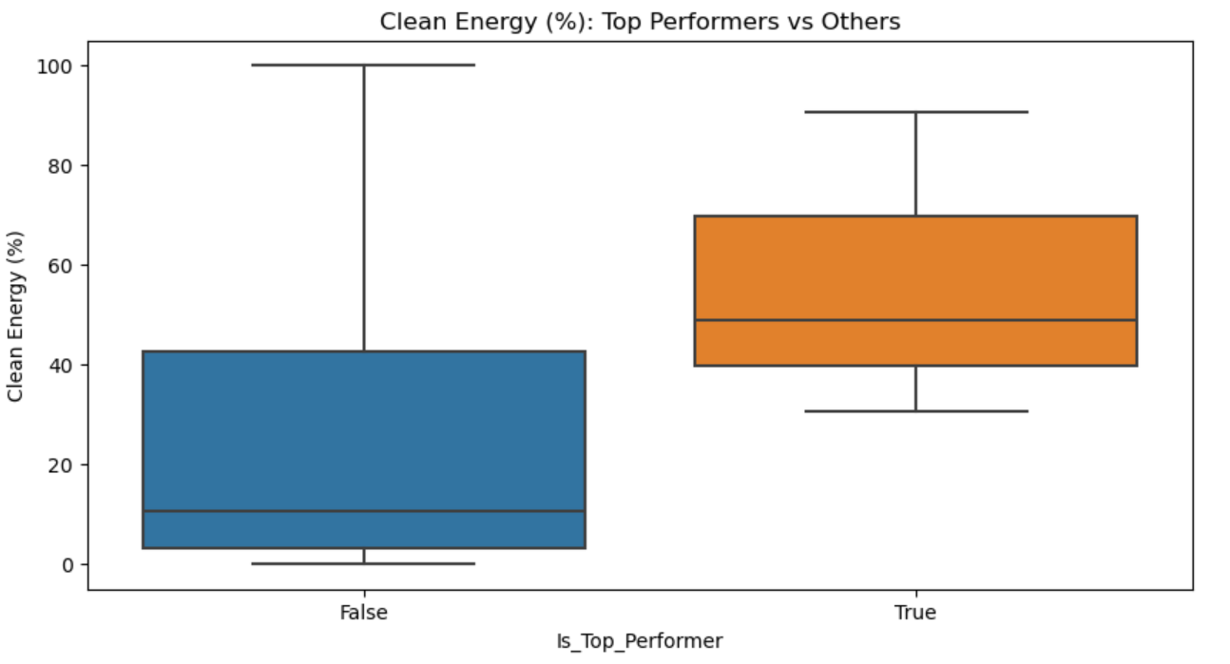

Box plot : Clean Energy (%) of Top Performing Countries vs. others.

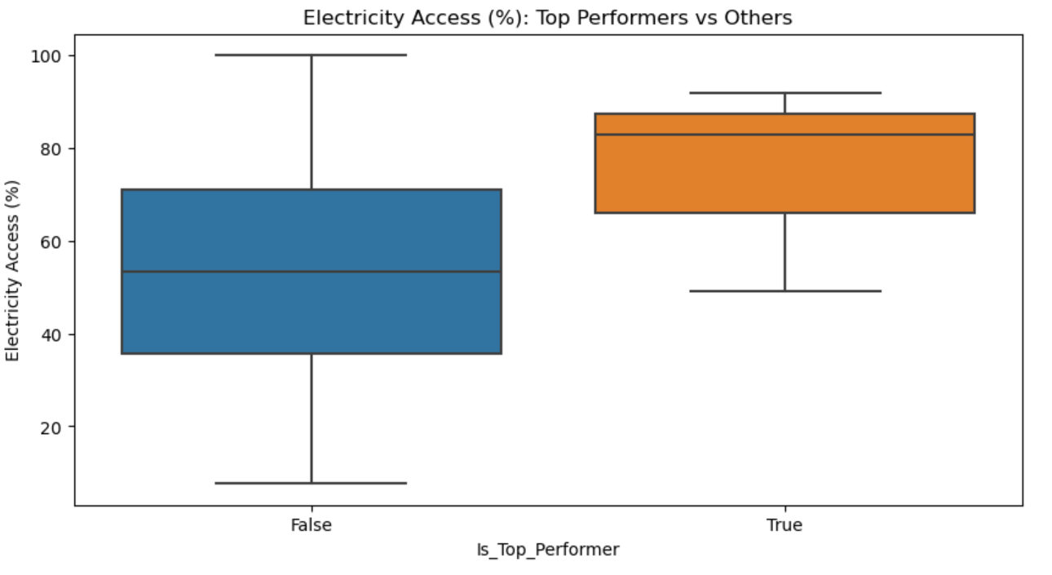

Box plot : Electricity Access (%) of Top Performing Countries vs. others.

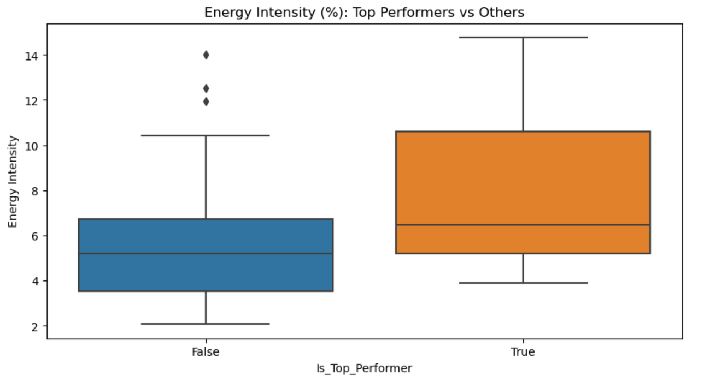

Box plot : Energy Intensity of Top Performing Countries vs. others.

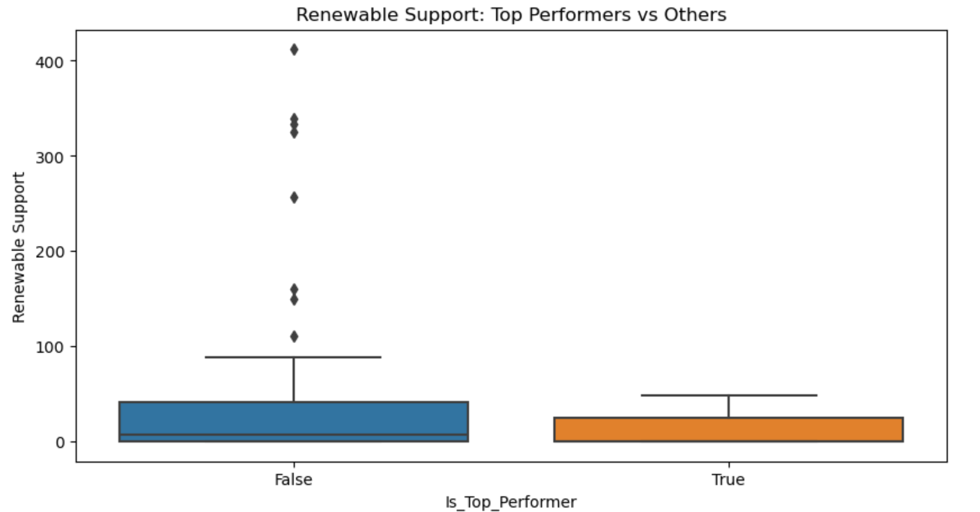

Box plot : Renewable Support of Top Performing Countries vs. others.

## Appendix E: Regression Results from OLS regression analysis

Appendix

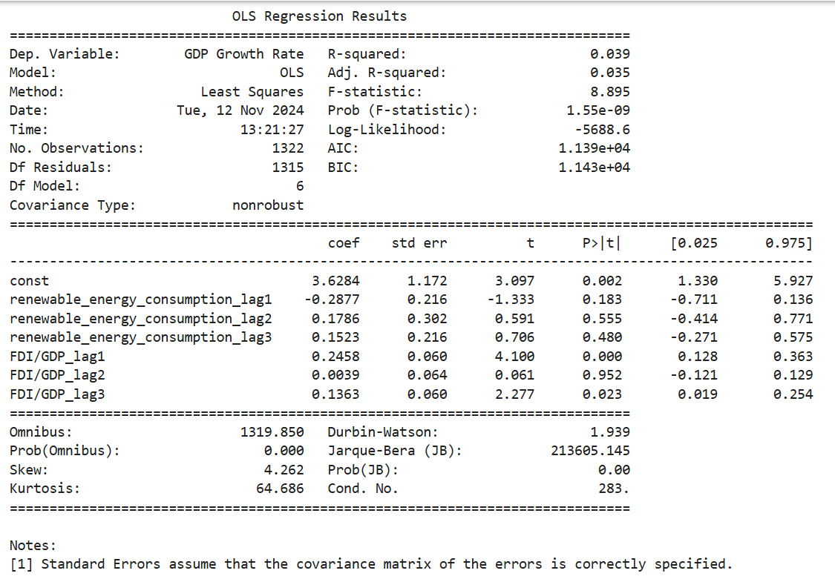

Table : OLS Regression Analysis